**Test Cases / User Story**

**SBA Connect Application**

**Small Business Administration**

Mehmet Ali Sultan

Alpha Omega Integration LLC

Version 1.0 March, 2020

Version 2.0 December, 2020

**Test Cases / User Story for SBA Connect**

### 1.0 Test Cases

### 1.01 SBAConnectSC-001 (Create and account and login to SBA Connect)

**Scenario:** External user successfully create new account

1. When user enter to SBA connect URL, user will redirected to the login.gov page.

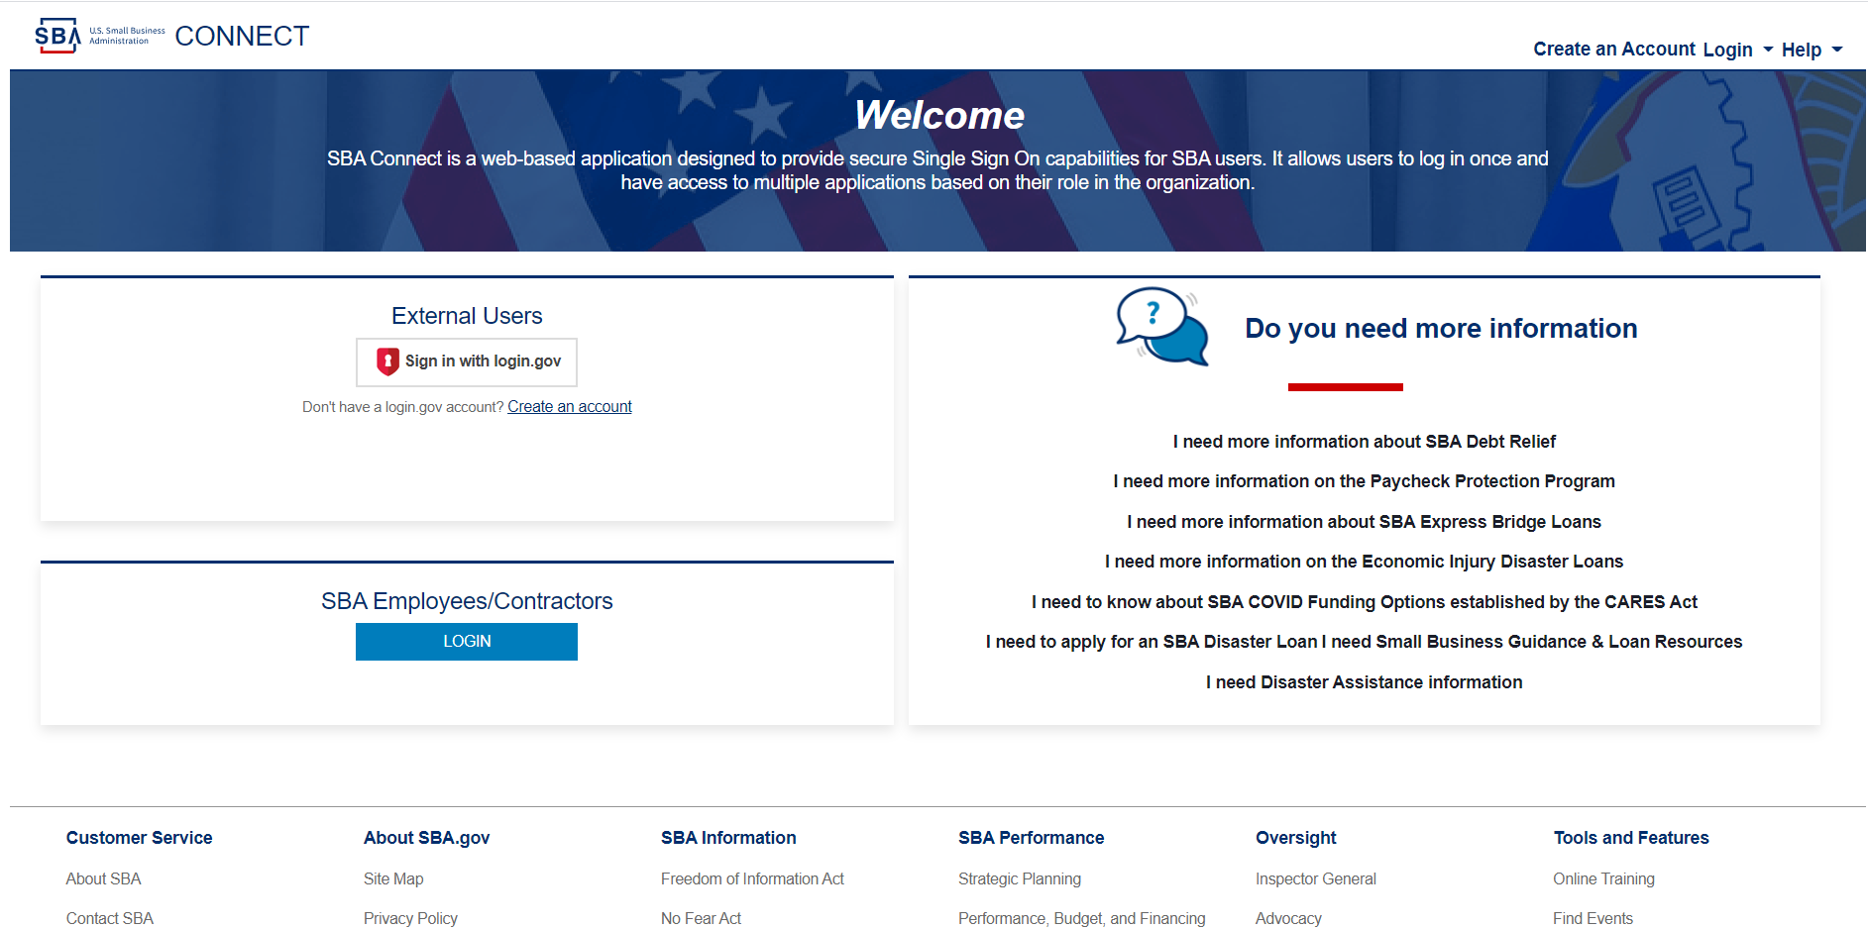

1. When user click the "Create an Account" link, system will navigate user to the “Terms & Conditions” Page.

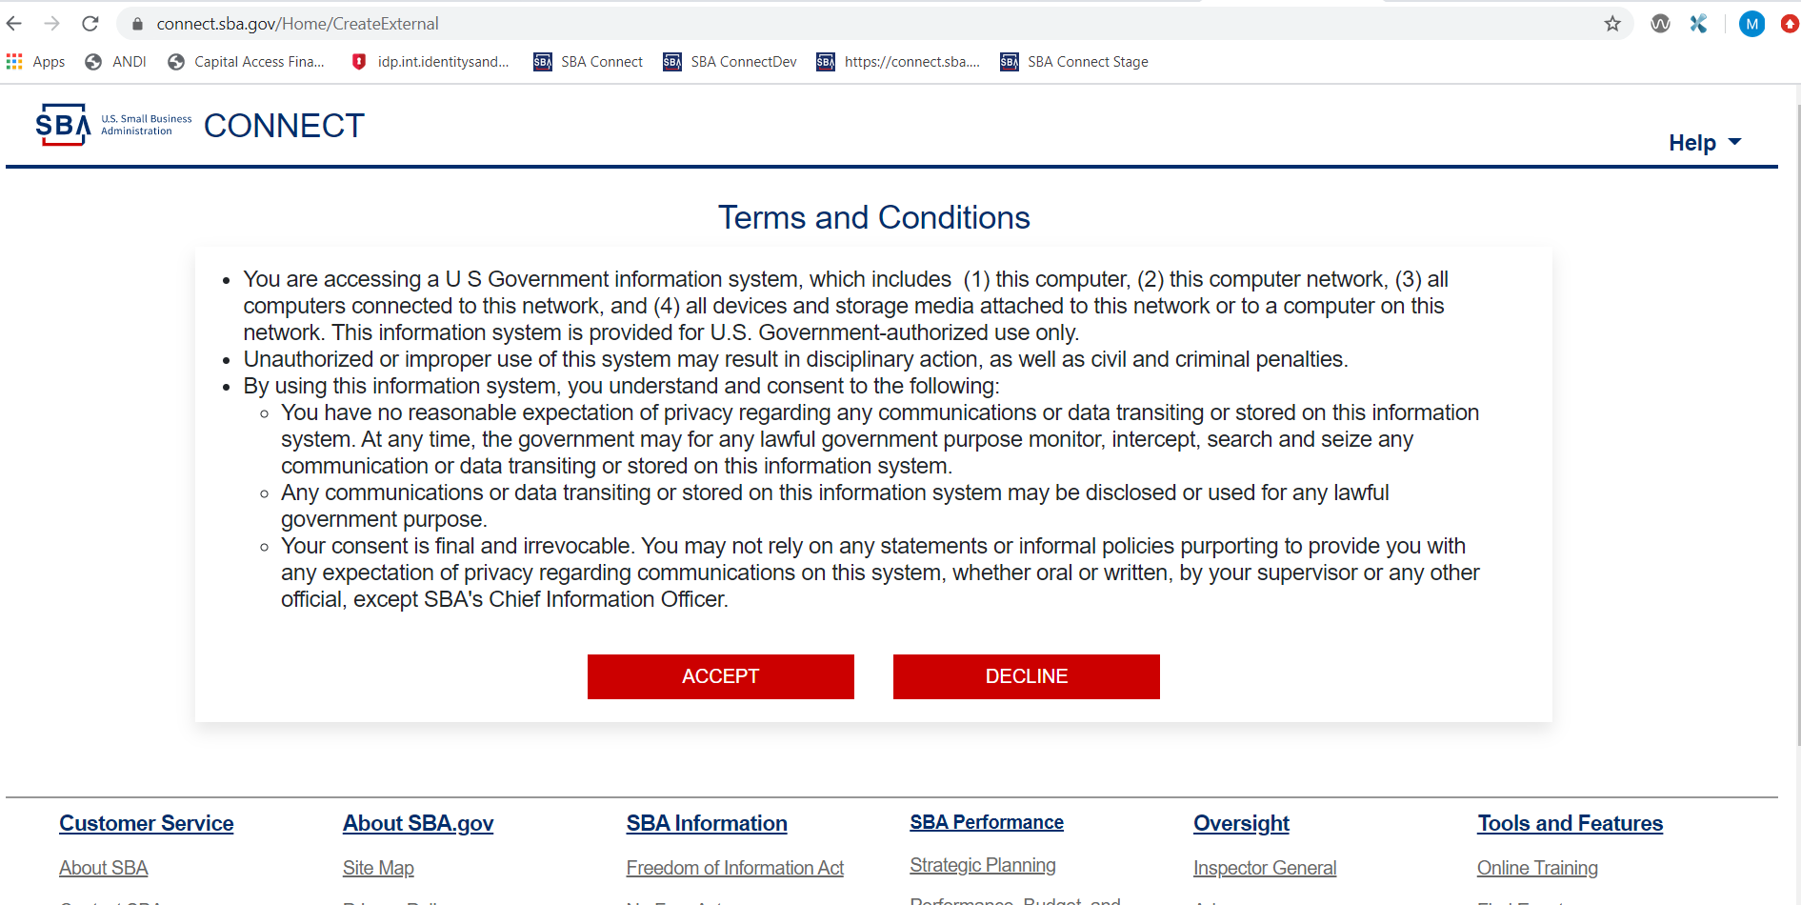

1. When user click the "Accept" button, user will redirected to the login.gov Sign In page.

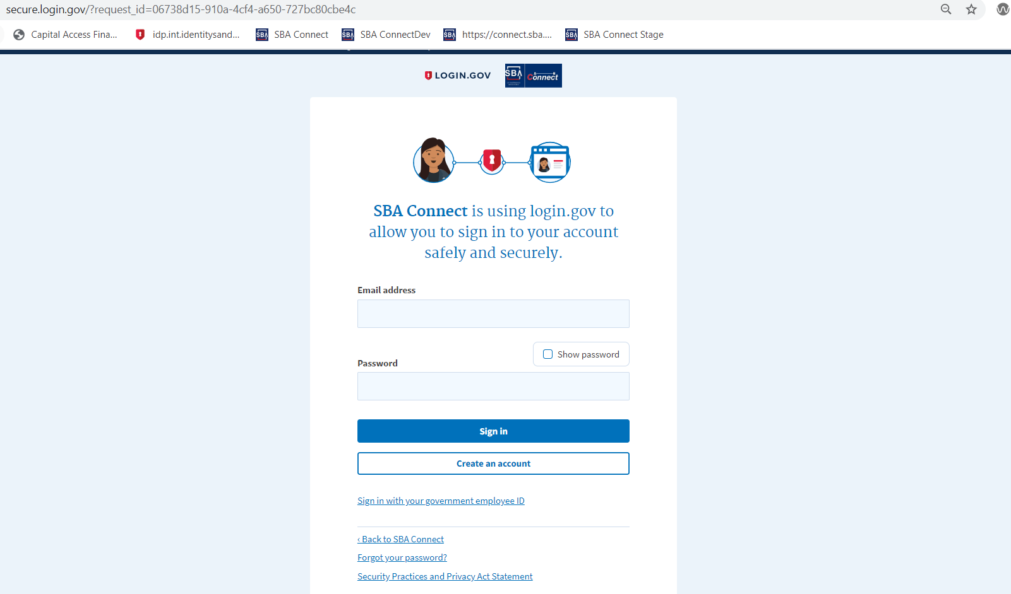

4. When user enter email and password click “Create an account” button, user will be redirected to the Enter email Page.

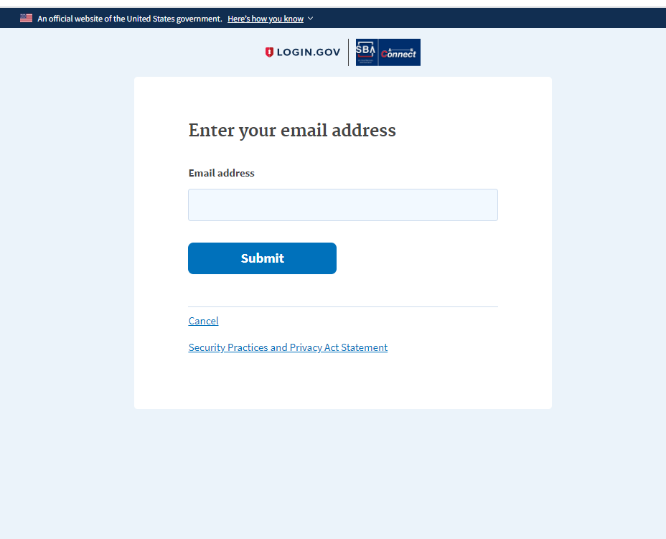

1. When user enter email and click “submit” button, user will be redirected to the email confirmation Page.

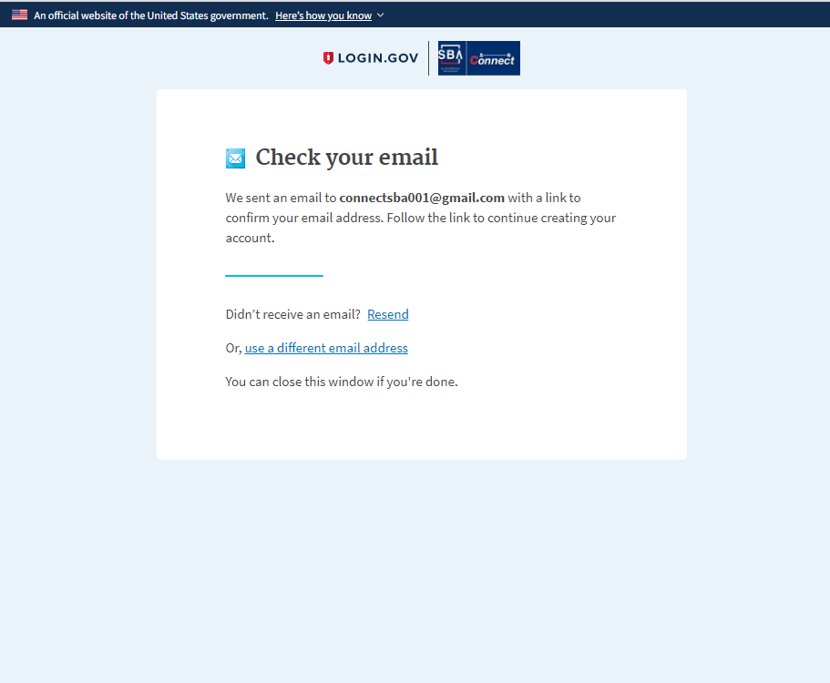

1. When user login to their email and click “Confirm email address”, user will be redirected to create password page.

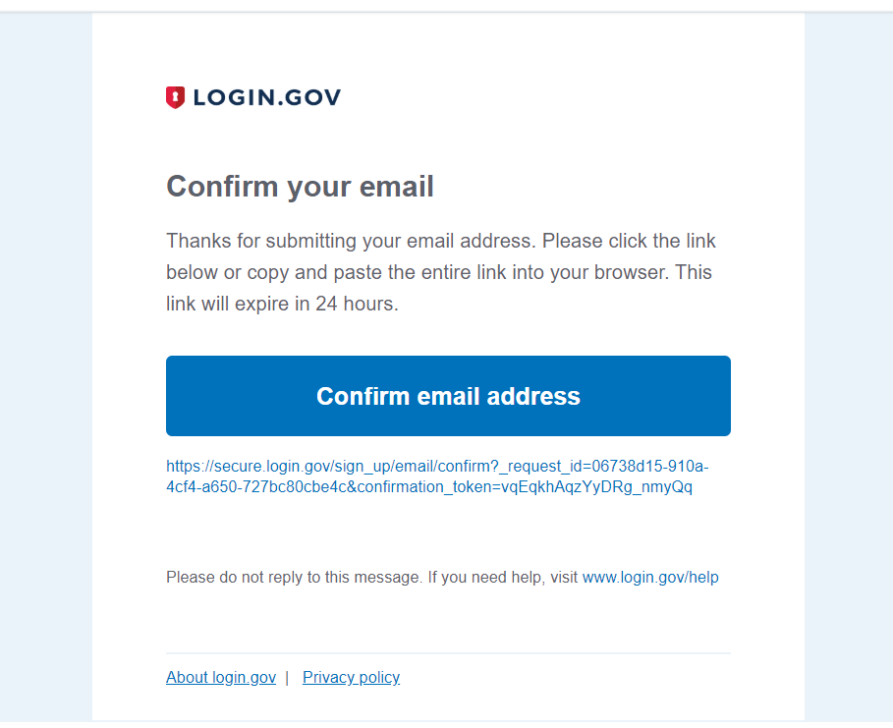

1. When user create a Password that meets Login.gov Password criteria and click “Continue”, user will be redirected to set up a secondary method of authentication.

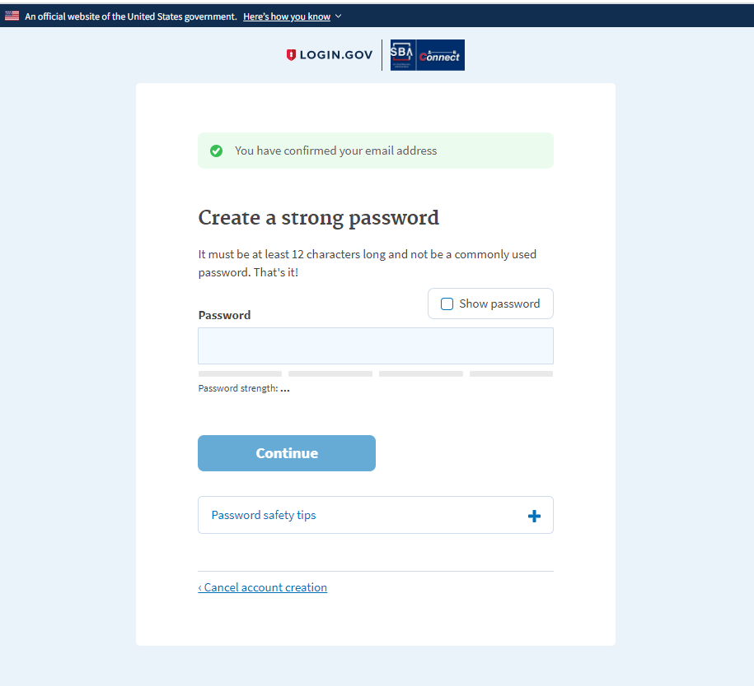

1. When user select the “phone” radio button (or one of the other methods) and click continue to be redirected to the page to set up the text messages for additional authentication.

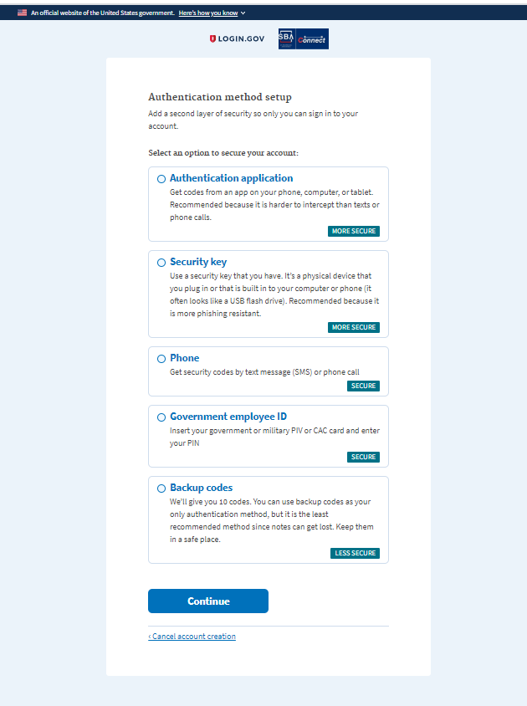

1. When user enter phone number, click “Text message(SMS)” and click send code, user will receive a text message containing a 6 digit code.

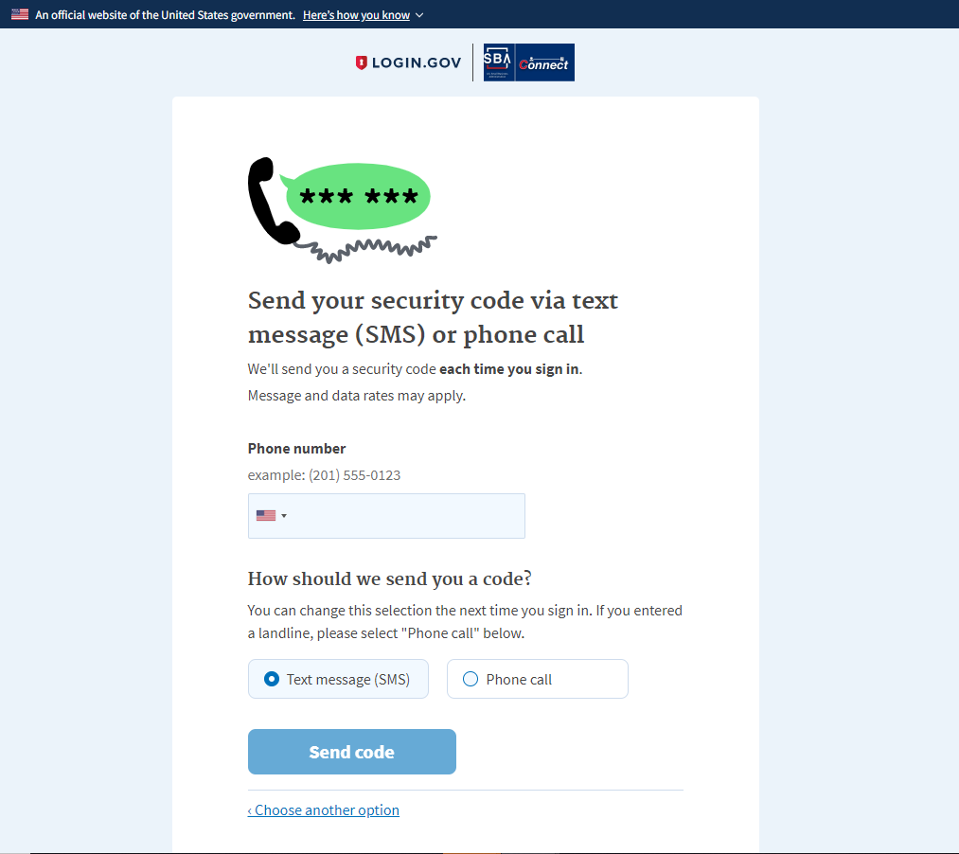

1. When user enter the code received on the phone and click “Submit” to be directed to select an additional secondary authentication method.

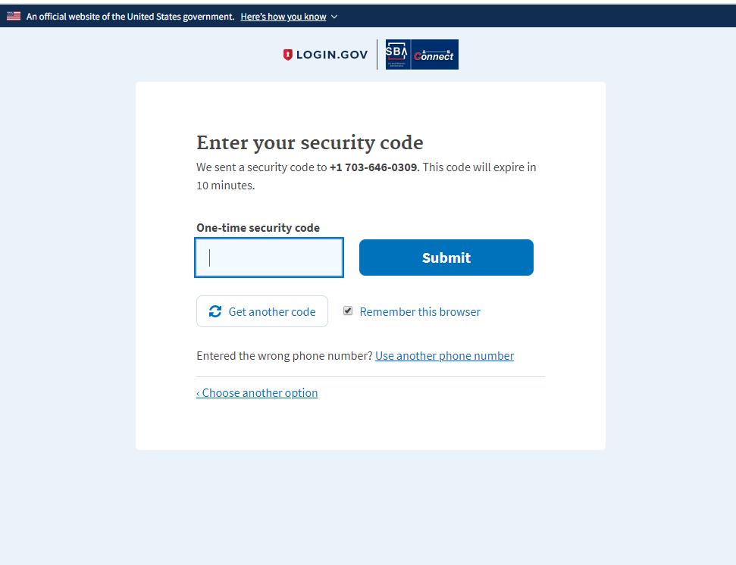

1. When user enter the code received on the phone and click “Submit” to be directed to select an additional secondary authentication method.

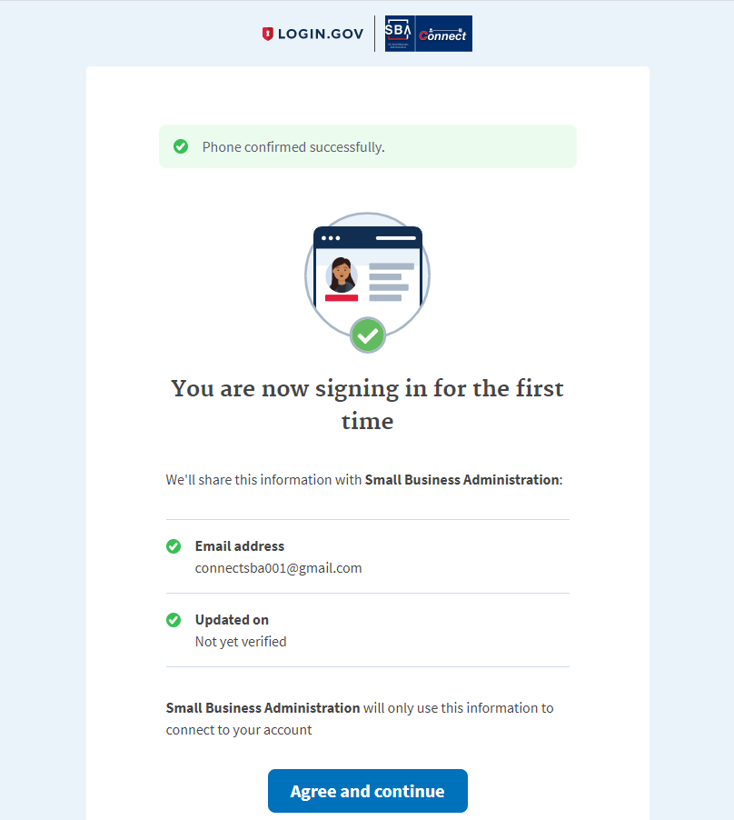

1. When user select the Authentication app code for second method, click Submit. User will be redirected to a confirmation screen and an email of successful Login.gov account creation will be sent.
2. When user click “Agree and continue” button the system redirect user to “Profile Information” Page.

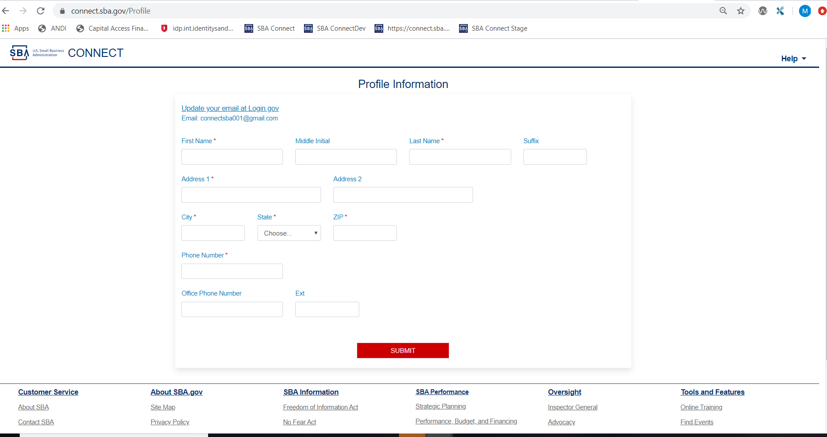

1. After update the user profile and click “SUBMIT” button, user will navigate to the “Request Access” Page.

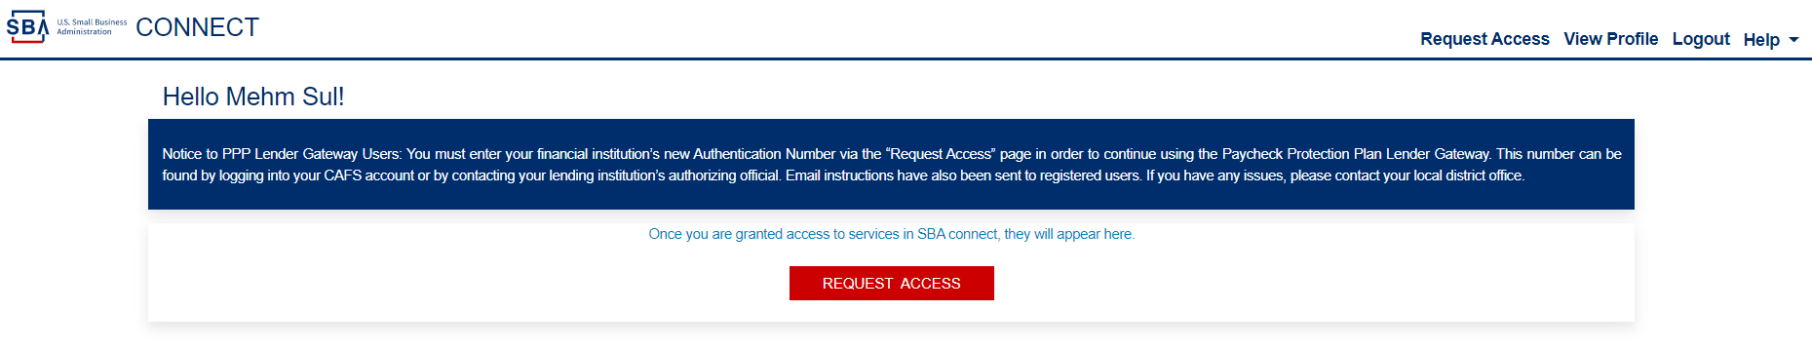

### 1.02 SBAConnectSC-002

**Scenario:** External user log in successfully to the existing SBA Connect account

1. When user enter to SBA connect URL, user will redirected to the login.gov page



1. When user click “Login” for existing Login.gov accounts as External user, user will be redirected to the “Terms & Conditions” Page.



1. When user click the "Accept" button, user will redirected to the login.gov Sign In page.



1. When user enter valid user name and password and click “Sign In” button, user will redirect to one time security code page and same time will able to receive code via text/email

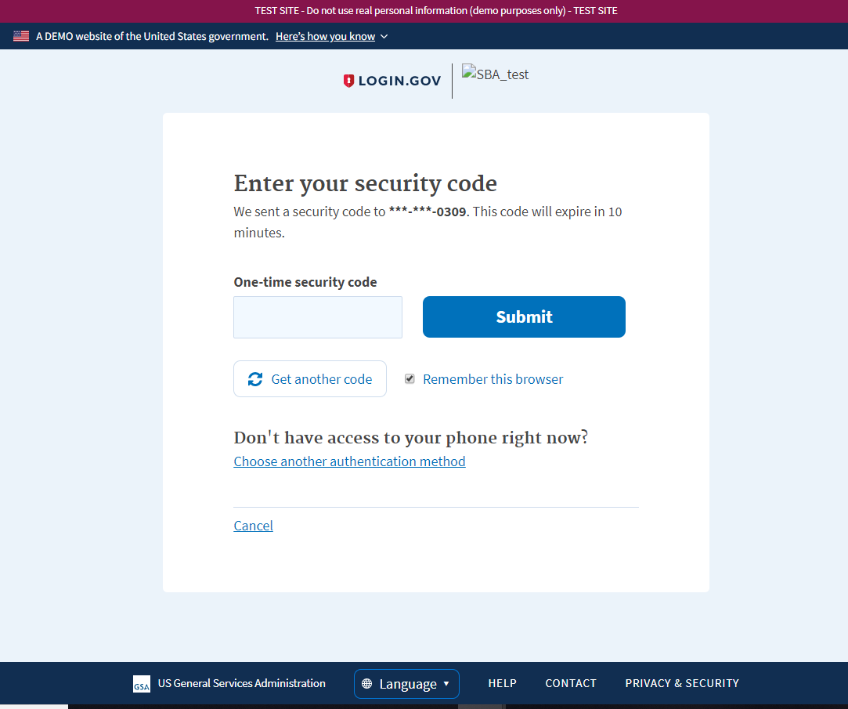

1. When user enter one time security code, received by phone and click submit button, user will able to login to Home/Landing page of SBA Connect.

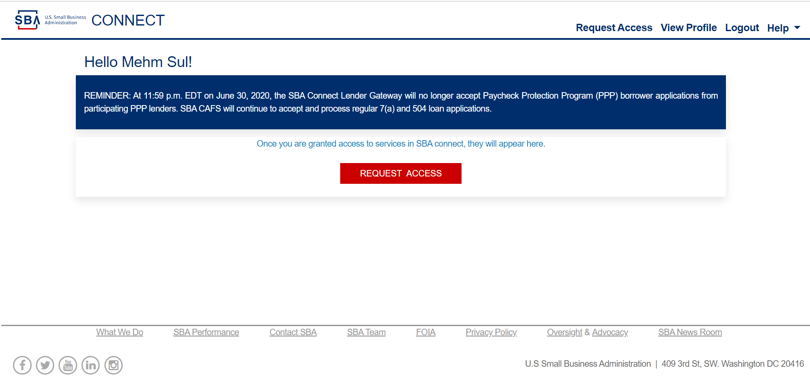

### 1.03 SBAConnectSC-22

**Scenario:** As a system User, I should able to successfully logging out from SBA connect.

1. User on the SBA connect home page (or any other pages of SBA Connect), and able to see Logout link top right corner before help link.

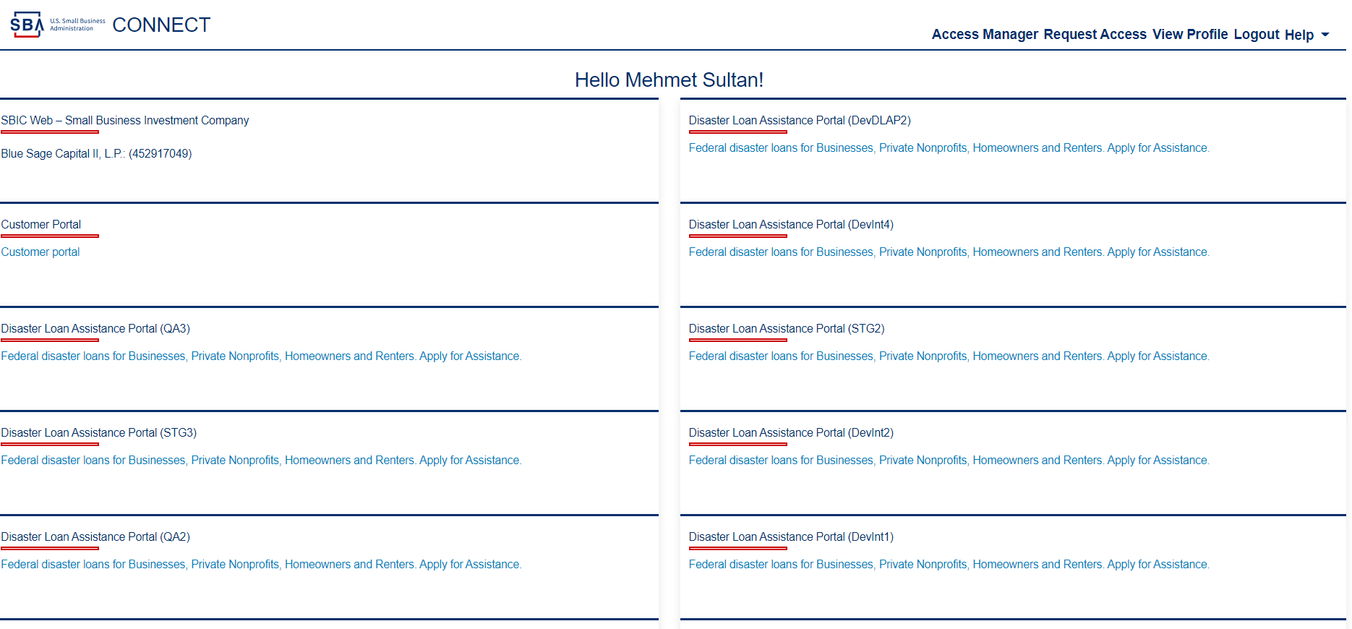

1. When user click logout link, system will direct the user to logout page, user able to logout and see the message “You have logged out successfully.”

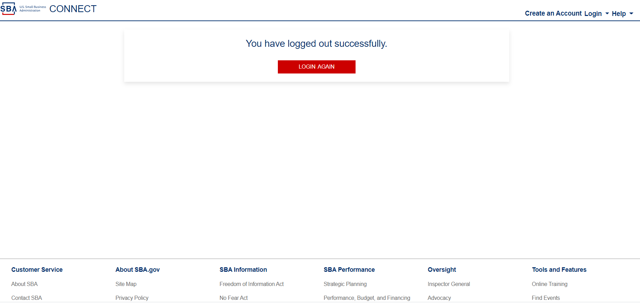

### 2.01 SBAConnectSC-33 (EDIMS)

**Scenario:** As an EDMIS portal User, I need to be able to request only one role at any given time.

1. When user log into SBA Connect, and click “Request Access” link or “Request Access” button, the user should navigate to the “Request Access” page, and able to see the EDMIS Application card.

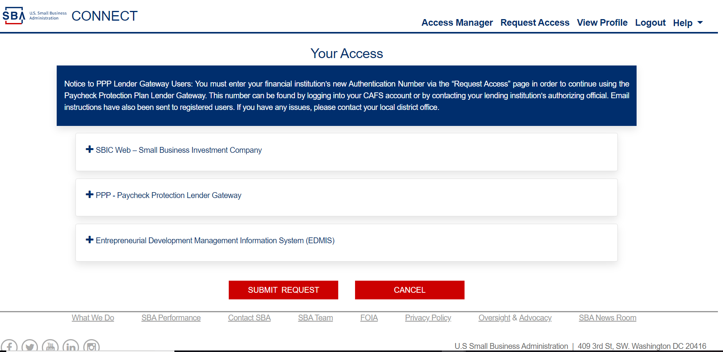

1. When user click the EDMIS Application, users should able to see a list of roles with checkboxes associated with different roles.

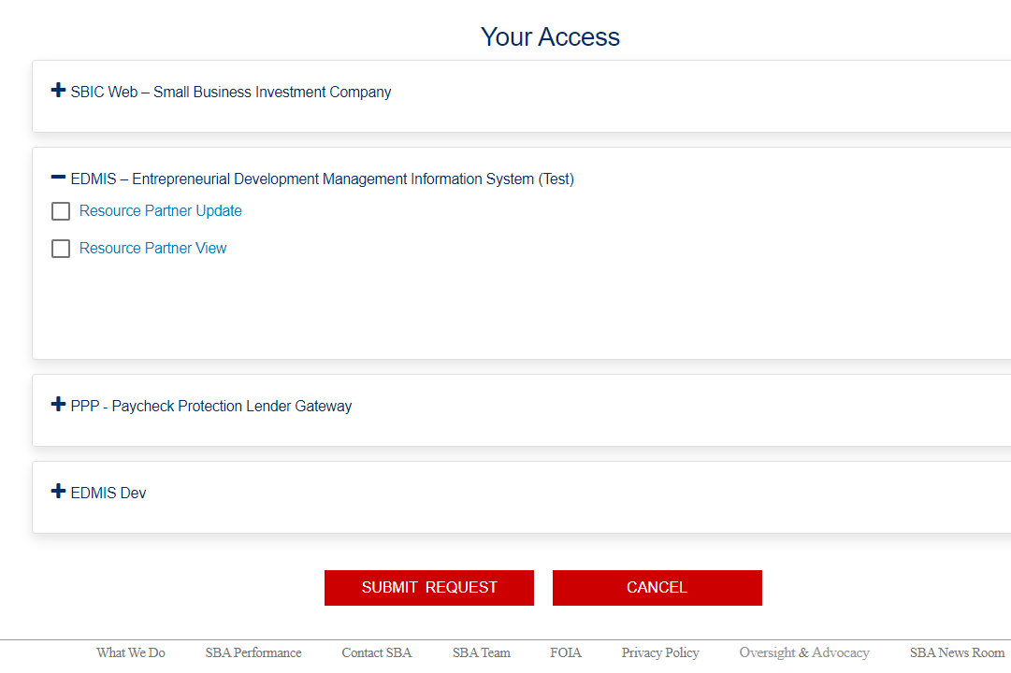

1. When user select “Resource Partner View" role, system will pop up the message windows with "Confirm Access Change” with blue color and following message and with “Yes” or “No” button.

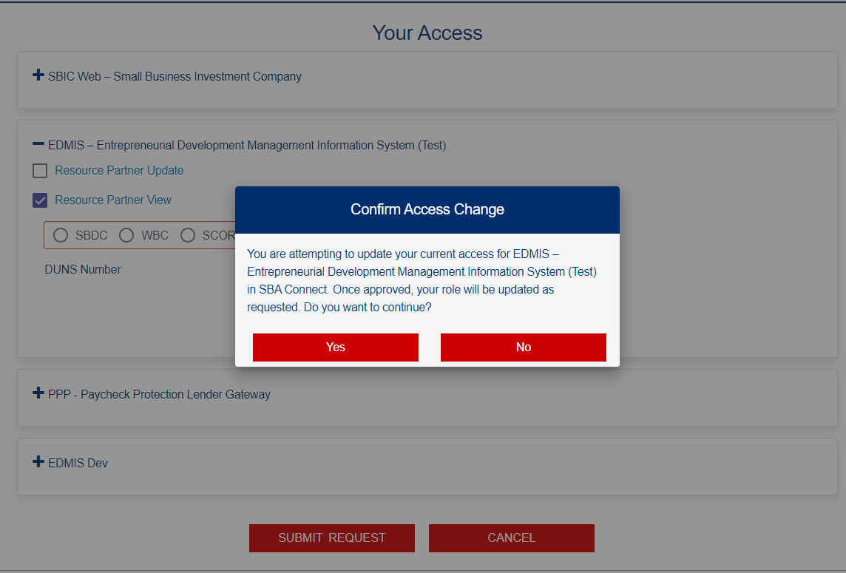

1. When user click "YES" button, pop up will disappears and input box for DUNS Number will appears.

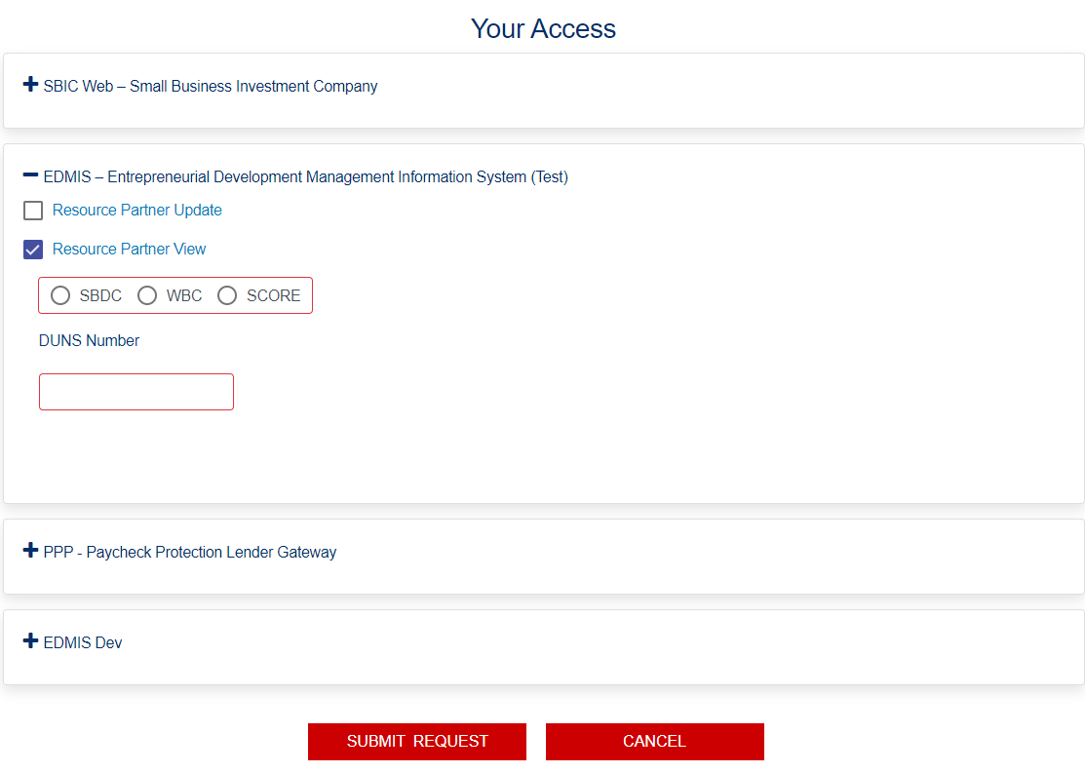

1. When user check one of the radio buttons and enter valid nine digit DUNS and click "Submit Request" button, the “Success” Message pops up.

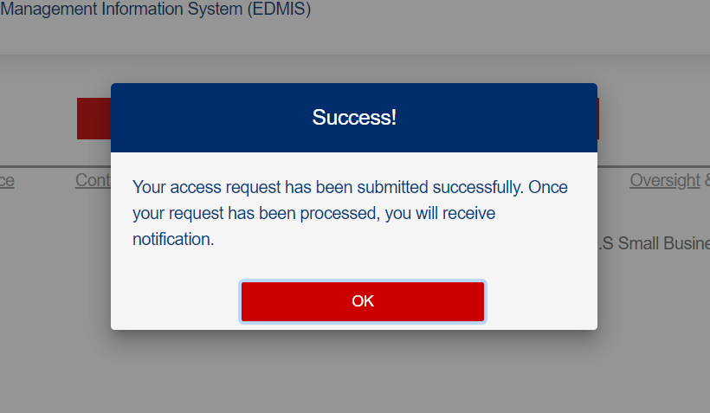

1. When user click the “OK” button, the message will disappears and the system navigate back to the “Request Access” page.

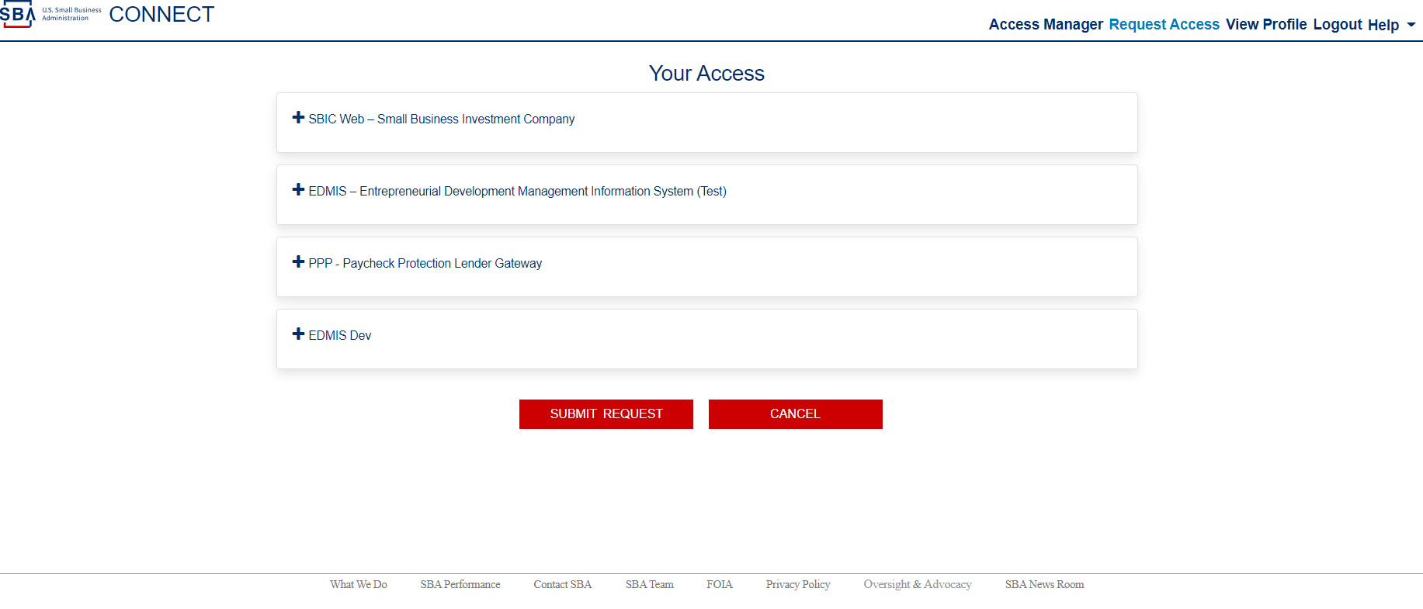

1. When user click the EDMIS Application again, will able to see the status is “Pending”.

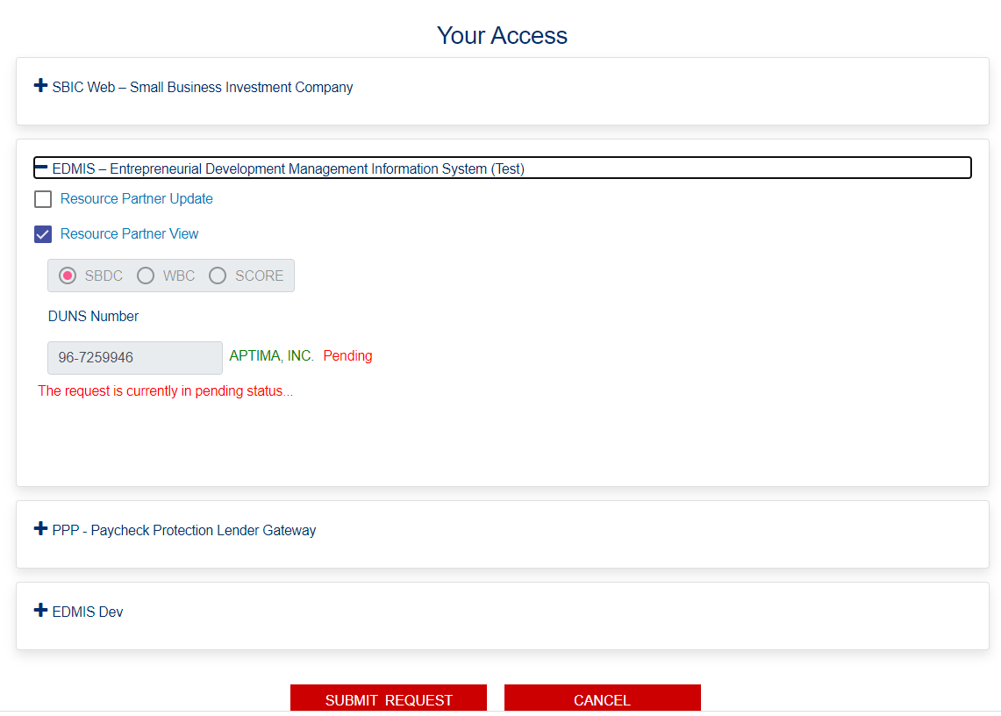

### 2.02 SBAConnectSC-12 (EDIMS)

**Scenario:** As a System User, I should be able to edit my current role(s), change role(s) or end role(s) from different Application so that I have acquired my new desired role(s).

**Scenario A:** ***Use able to change current “Pending” Role:***

1. When user status show as "Pending", the user able to change their role to another role with clicking the new checkbox.



1. When user click the new checkbox, the system will pop up warning message with title "Confirm Access Change" and "You are attempting to update your current access for Entrepreneurial Development Management Information System (EDMIS) in SBA Connect. Once approved, your role will be updated as requested. Do you want to continue?" (Text) and with “Yes” or “NO” (button).

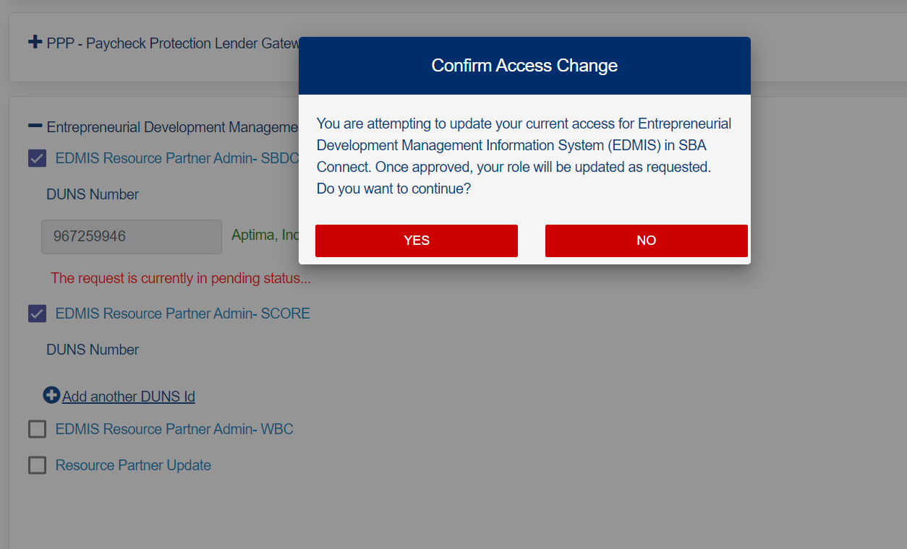

1. When user click "YES" button, pop up will disappear and the input box for DUNS will appears, and user should able to enter nine digit valid DUNS number.

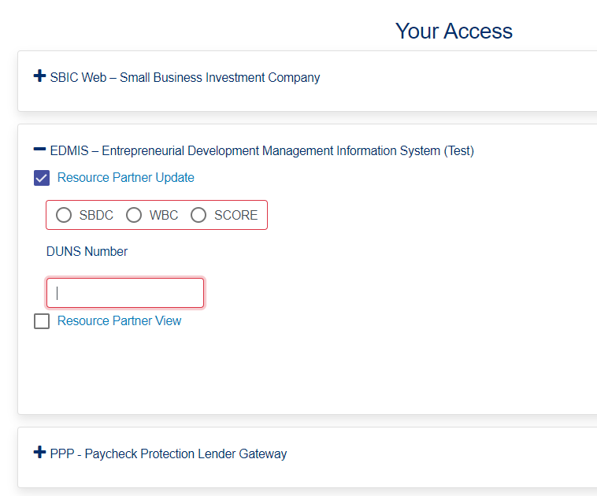

1. When user enter nine digit valid DUNS, the system will accept and the financial institution name appears with (green color) right of input box.

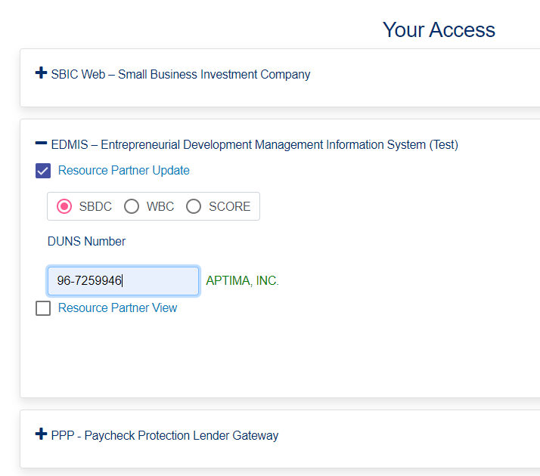

1. When the user click “Submit Request” button, the "Success!" will pops up.

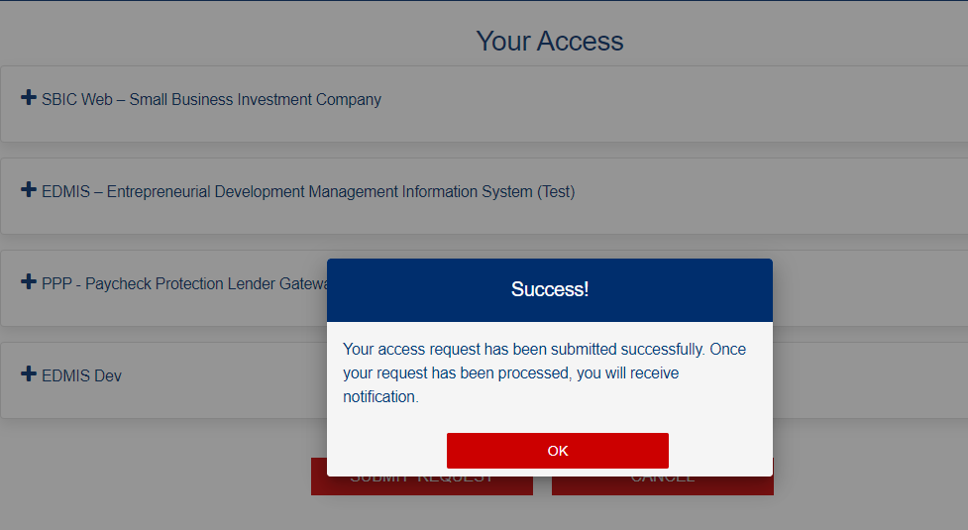

1. When user click "OK" button, the system navigate back the user to "Request Access” Page

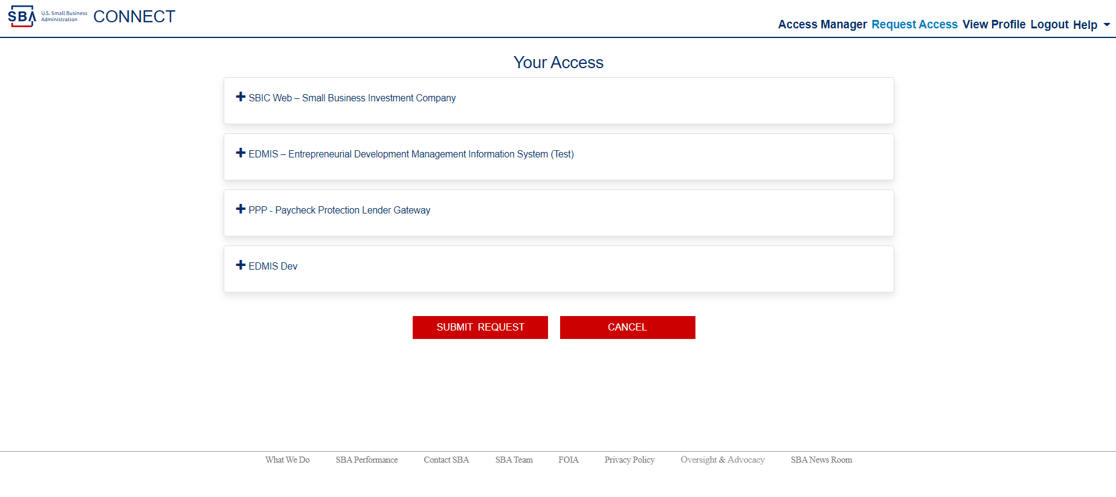

1. When the user checks the application, the request Status will be show as "Pending"

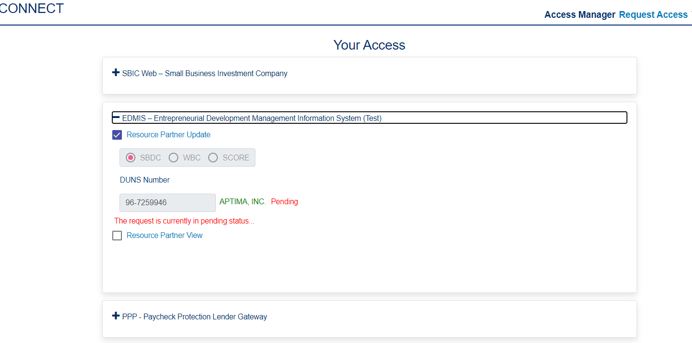

**Scenario B: *Use able to delete current “Pending” Role:***

1. When user click the checkbox the status show as "Pending", the system will pop up warning message windows with "Existing Access Role will be Replaced" and "You have chosen to remove this role, are you sure?" with “YESY and “NO” button.

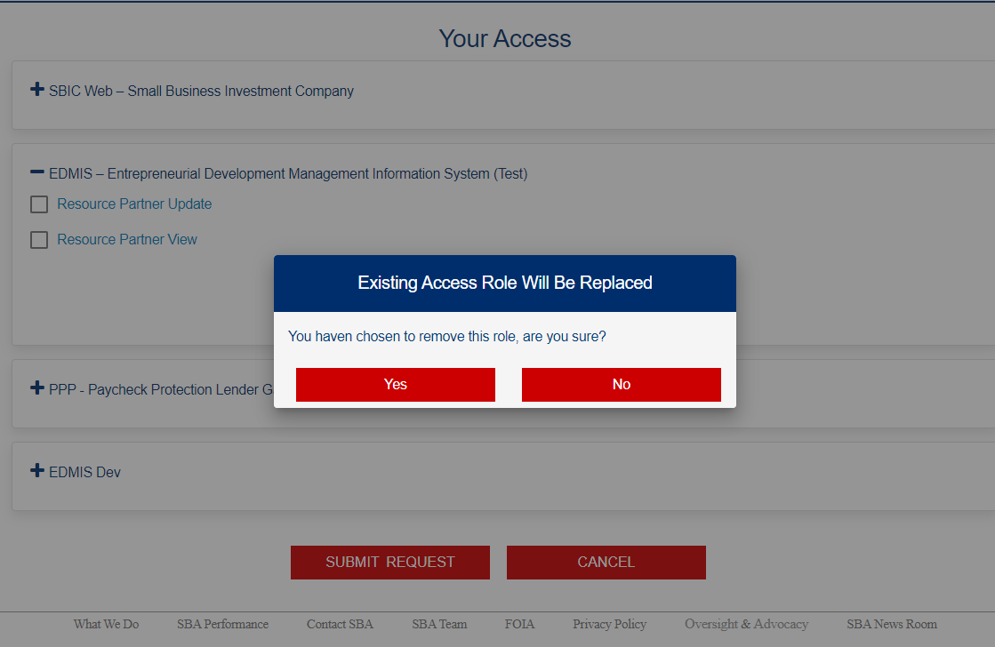

1. When user click "YES" button, pop up will disappear and the system navigate back to request access page.

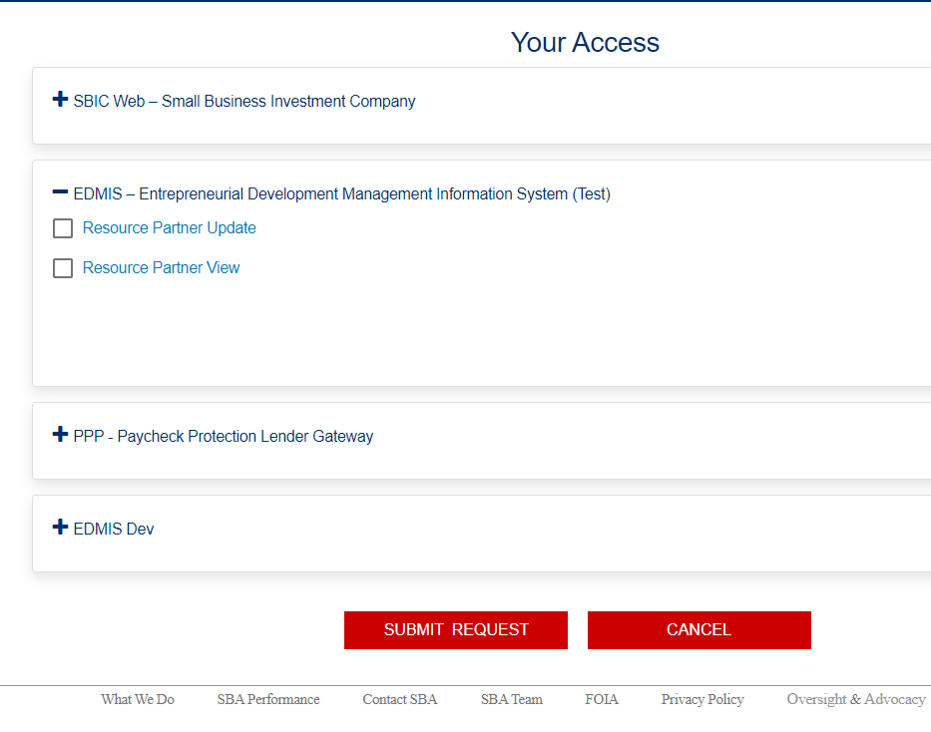

1. When user click “Submit Request” button, the “Success” message will be pops up.

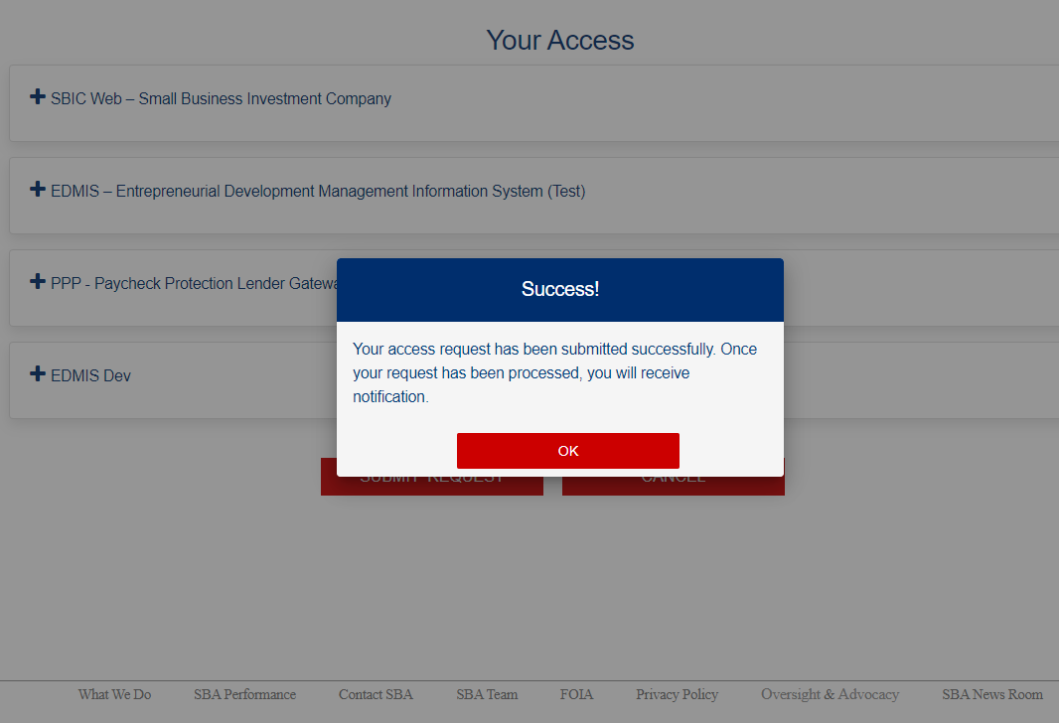

1. When user click “OK” button, the system will navigate back to “Request Access” page, the pending status disappears.



**Scenario C: *Invalid entry for role request:***

1. When user click the new checkbox of one of the role on request access page, the system will pop up the message with title "Confirm Access Change" and "You are attempting to update your current access for Entrepreneurial Development Management Information System (EDMIS) in SBA Connect. Once approved, your role will be updated as requested. Do you want to continue?" (Text) and with “Yes” or “NO” (button).

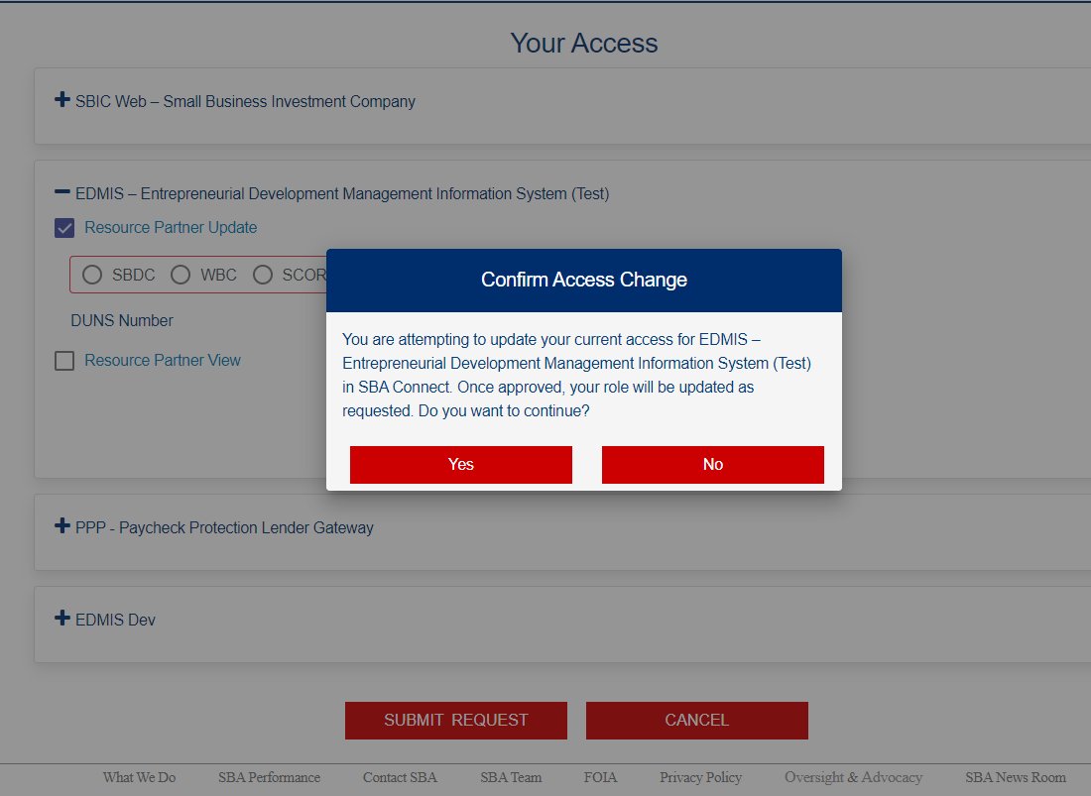

1. When user click "YES" button, pop up will disappear and the input box for DUNS will appears, and user should able to enter nine digit valid DUNS number.

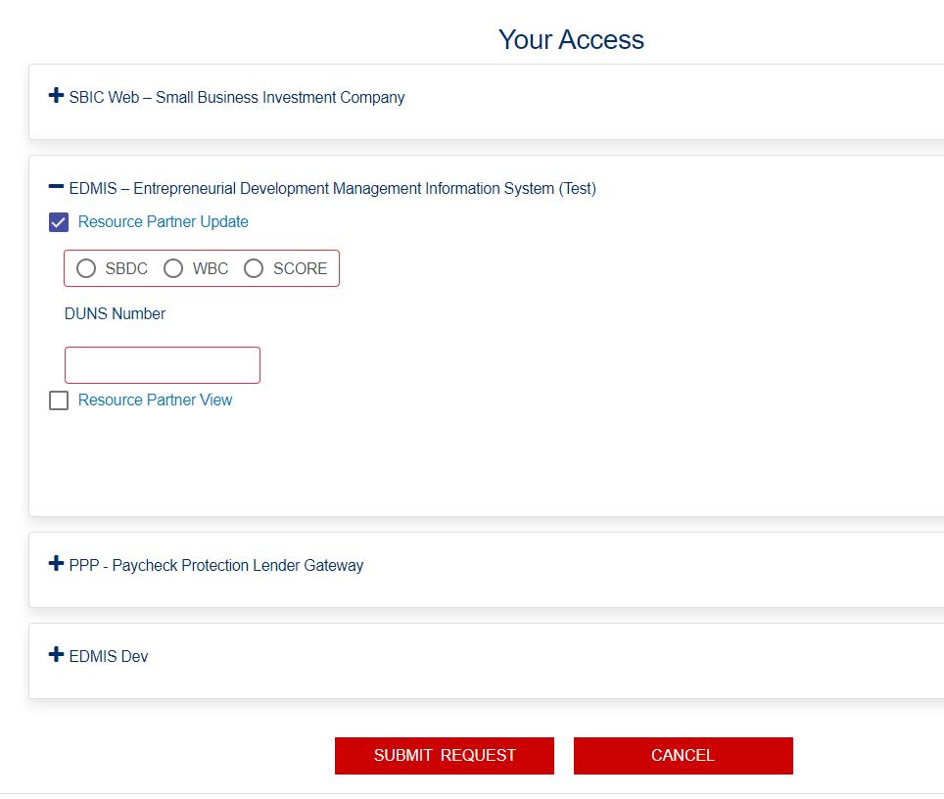

1. When the user select a radio button and enter invalid number, the status shown a message "Invalid input" with red color.

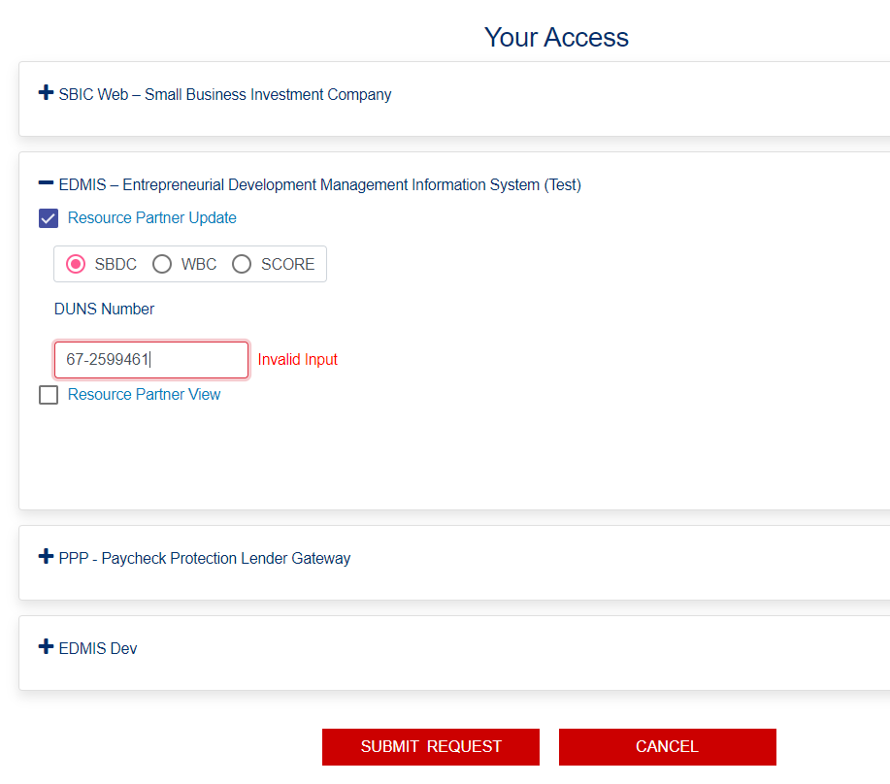

1. When user click Submit Request button, the system will pop up an error message "Please fix input errors"
2. User should either enter valid DUNS to continue or click “Cancel” button to cancel requesting process.

### 3.01 SBAConnectSC-18 (Access Manager Roles)

**Scenario:** As an approver/Access Manager, user should be able to view the Role Management Screen, so that I can approve the access request of users.

1. As an approver when user click the "Access Manager" link on the Home Page, system will redirect the user to Access Manager Page and the system will displays the users detail information.

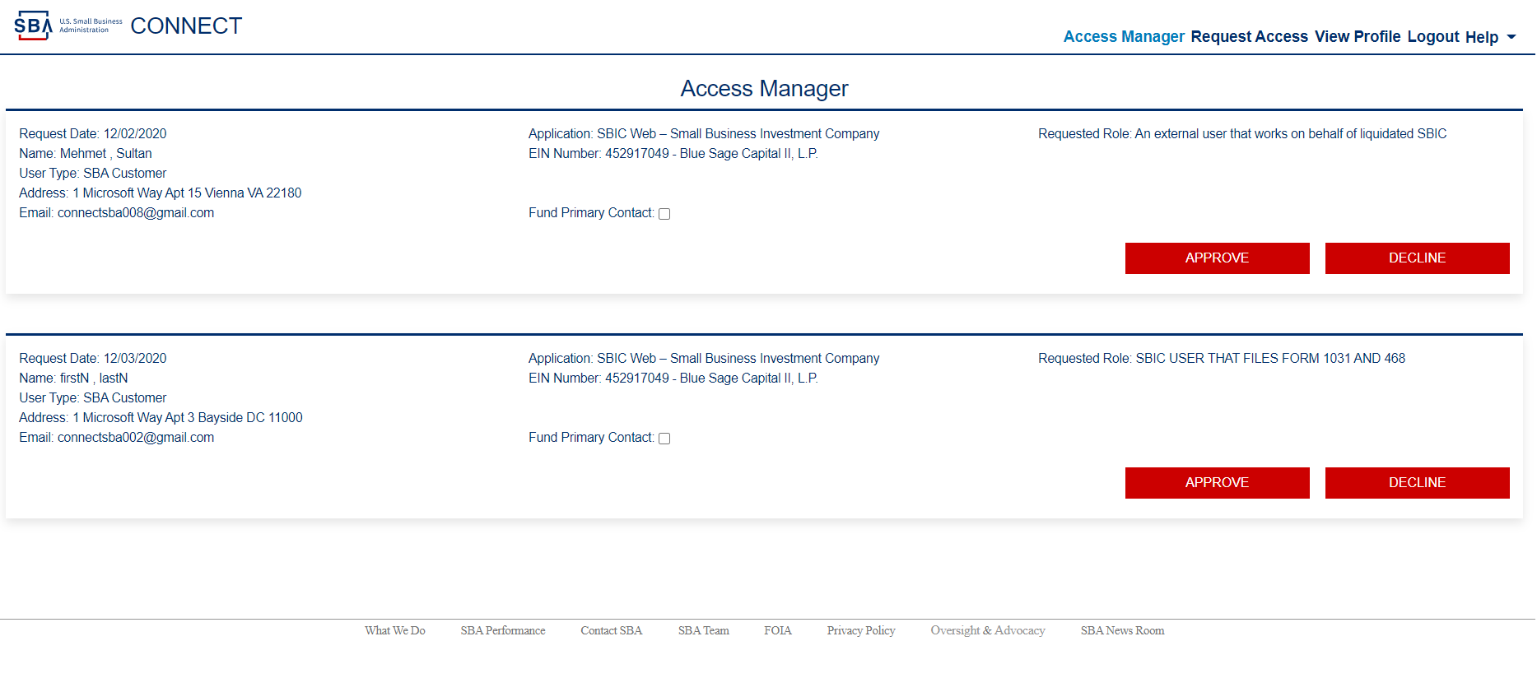

1. When user click "Fund Primary Contact:" checkbox (the check box will checked and the user will be become primary contact) and click approve button, system will displays a pop up message "Request Approved Successfully"

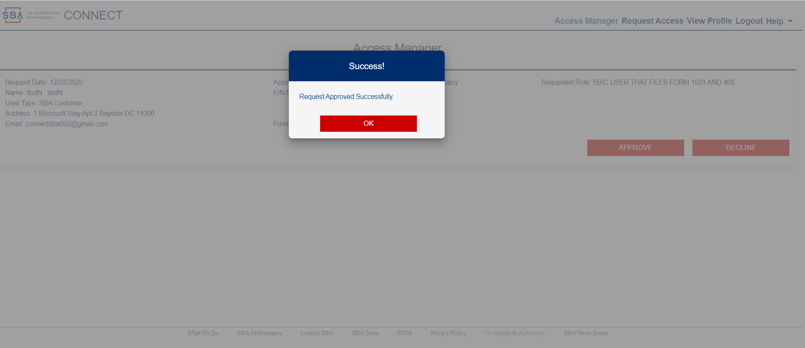

1. When user click Ok button, the system will navigate back to user to Access Manager Page and the requested role information disappears.

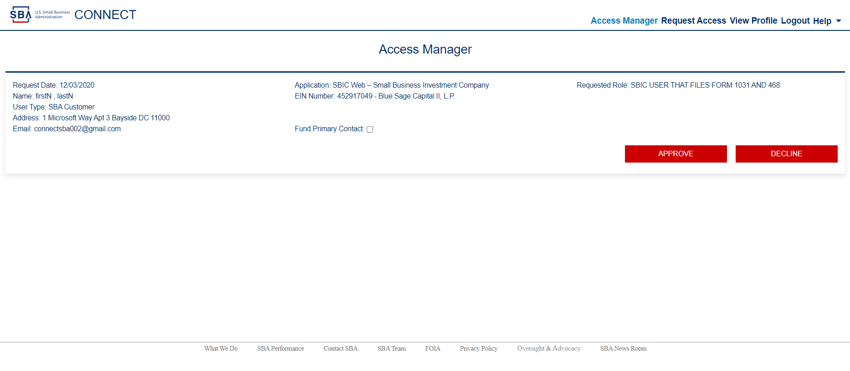

1. When user navigates to the SBA Connect home page, user able to see the approved for the SBIC Web application, and ‘Access Manager’ link of the right top corner.

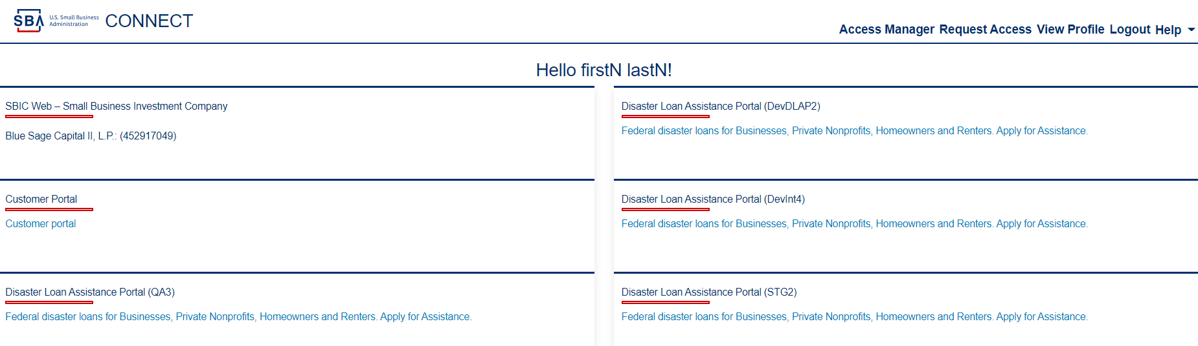

### 3.02 SBAConnectSC-18 (Access Manager Roles)

**Scenario:** As an approver/Access Manager, user should be able to view the Role Management Screen, so that I can approve user (without click "Fund Primary Contact" user can’t get Access manager role) the access request of users.

1. As an approver when user click the "Access Manager" link on the Home Page, system will redirect the user to Access Manager Page and the system will displays the users detail information.



1. When user without click "Fund Primary Contact" and click approve button, system will displays a pop up message "Request Approved Successfully"



1. When user click Ok button, the system will navigate back to user to Access Manager Page and the requested role information disappears.



1. When user navigates to the SBA Connect home page, user able to see the approved for the SBIC Web application, but not ‘Access Manager’ role.

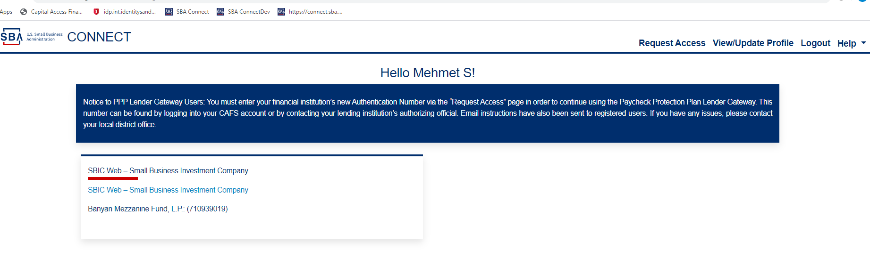

### 3.03 SBAConnectSC-18 (Access Manager Roles)

**Scenario:** As an approver/Access Manager, user should be able to view the Role Management Screen, so that I can delete/reject the access request of users.

1. As an approver when user click the "Access Manager" link on the Home Page, system will redirect the user to Access Manager Page and the system will displays the users detail information.



1. When user click the ‘Decline’ button, system will displays a pop up message "Request Declined Successfully"

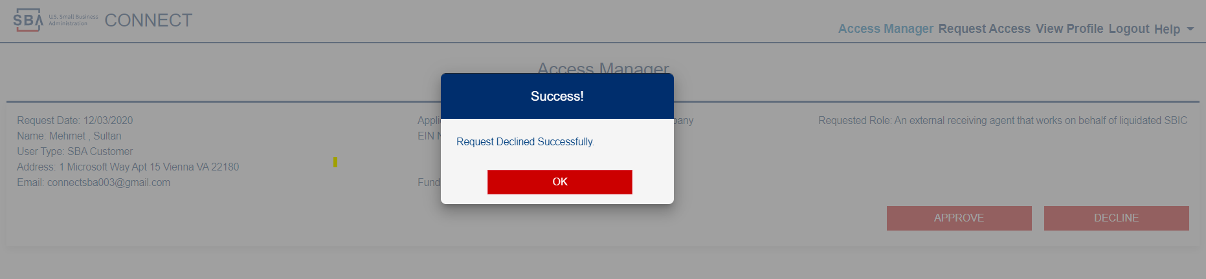

1. When user click Ok button, the system will navigate back to user to Access Manager Page and the requested role information disappears.



1. When user(who the request the role) login to the SBA Connect home page, user not able to see the approved for the SBIC Web application or ‘Access Manager’ role.

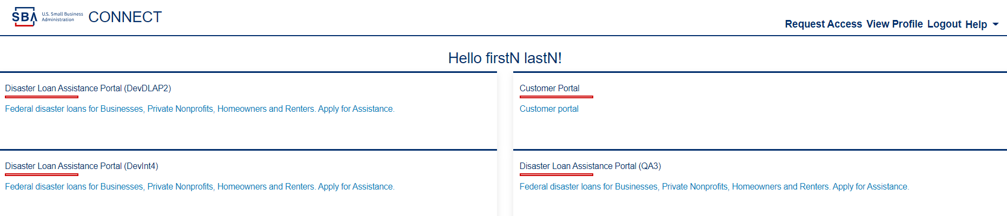

1. When user (who the request the role) navigates to the request access page, user will see the role request got deleted.

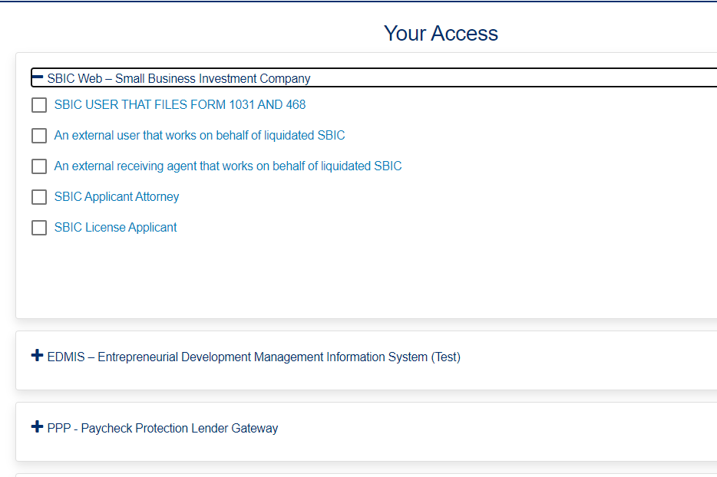

### 4.01 SBAConnectSC-17 (Receiving status emails)

**Scenario:** As an approver/Access Manager, user should be able to view the Role Management Screen, so that I can approve the access request of users.

1. User will request a role for “An external user that works on behalf of liquidated SBIC”
2. The Access Manager will receive an email.
3. The Access Manager will need approve it as “Fund Primary Contact”
4. That user able to see the “SBIC Web – Small Business Investment Company” card and the ‘Access Manager’ link on the Home Page and can act as Fund primary contact.
5. The same EIN status appears as “Approved” on the Request Access/ Your Access page.

**Scenario:** As an approver/Access Manager, user should be able to view the Role Management Screen, so that I can approve user (without click "Fund Primary Contact" user can’t get Access manager role) the access request of users.

* + - 1. User request for same role using same EIN, the ‘Approver/Access Manager will approve the role without checking “Fund Primary Contact” checkbox.
      2. That user can see the “SBIC Web – Small Business Investment Company” card but can’t see the Access Manager link on the Home Page/Dashboard and can’t act as Fund primary contact.
      3. When User B deletes the existing role, then request two more roles (in them one is same EIN with User A)

**Scenario:** As an approver/Access Manager, user should be able to view the Role Management Screen, so that I can delete/reject the access request of users.

1. User request a role for “An external user that works on behalf of liquidated SBIC”
2. User will get decline/rejected.
3. That User B can’t see the “SBIC Web – Small Business Investment Company” card and the Access Manager link on the Home Page/Dashboard.
4. The role request status will be empty on the Request Access/ Access page

**Scenario:** As an approver/Access Manager, user should be able to view the Role Management Screen, so that I can delete/reject the access request of users.

1. Then User A can approve the one with same EIN.
   1. That User B can see the “SBIC Web – Small Business Investment Company” cart and the Access Manager link on the Home Page/Dashboard and can act as Fund primary contact.
   2. The with same EIN status appears as “Approved”, the Other role with different EIN stays as pending on the Request Access/ Access page

### 4.01 SBAConnectSC-17 (Receiving status emails)

**Scenario:** As a System User, I should receive a confirmation email associated with my account when I check the boxes alongside the roles I want and click the 'Request Access' button, so that I have a reference to the roles that I requested.

As a supervisor or approver, I should receive an email when a user (or users) requests a role (or roles) to an application (or applications), so that I have a reference of the user(s) request.

1. When user A request a role for “An external user that works on behalf of liquidated SBIC”, the Access Manager will receive a role request email.

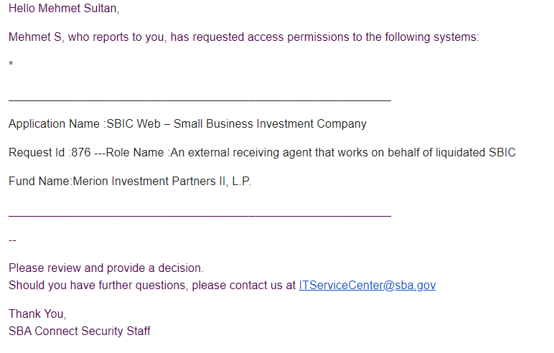

1. The user also receive an email for the request status.

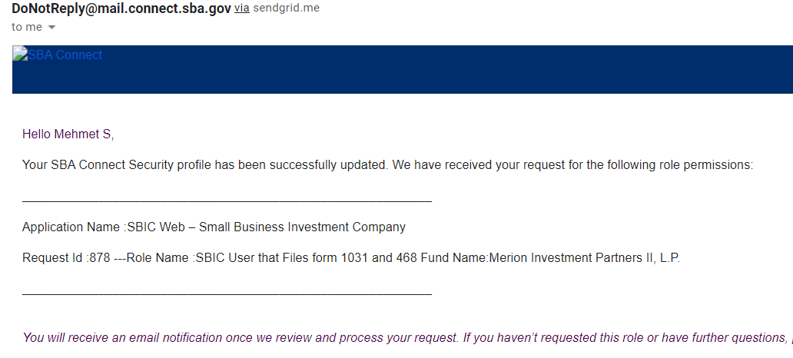

1. When the Access Manager approve the request as “Fund Primary Contact”, the user receive an email about the role details and Status “Approved”.

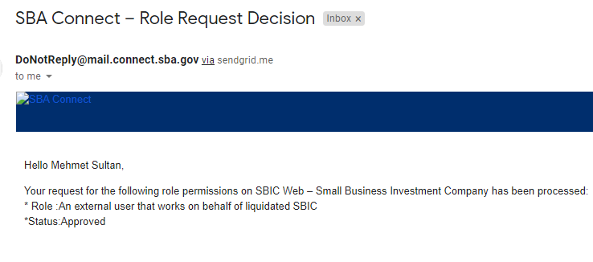

1. The user could able see the Access Manager link on the Home Page/Dashboard and can act as Fund primary contact.

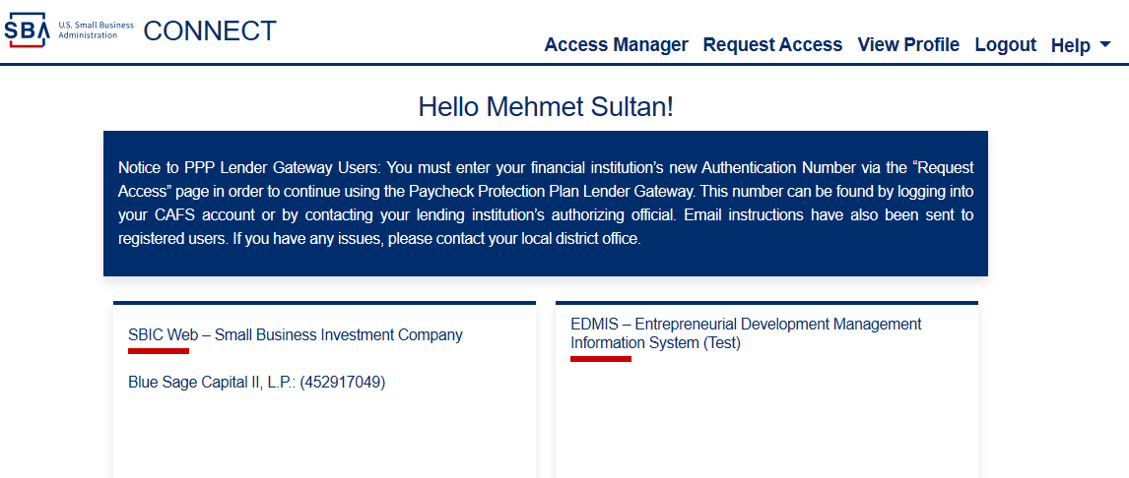

### 1.07 SBAConnectSC-22

**Scenario:** As a system User, I should able to successfully logging out from SBA connect.

1. User on the SBA connect home page (or any other pages of SBA Connect), and able to see Logout link top right corner before help link.



1. When user click logout link, system will direct the user to logout page, user able to logout and see the message “You have logged out successfully.”



### 1.08 SBAConnectSC-20

**Scenario:** As a system user, I should receive a decision email, so that I know if my role requests have been approved or denied. Modernize the email template

1. When user a request a role, the user receive an email about the request status.



1. When the Access Manager approve the request, the user will receive an email about the role details and Status “Approved”.



### 1.09 SBAConnectSC-22

**Scenario:** As a system User, user should be redirected to SBA connect, so that I am sure of successfully logging out

When I click on the logout button from TSS application, user should be redirected to SBA Connect. If my session times out in SBA Connect, user shall be prompted to login again.

### 1.10 SBAConnectSC-26

### Scenario: External users should be redirected to Connect/Login.gov for authentication when they login from Certify portal

1. When user click login as an external user, users should be redirected to Connect/Login.gov for authentication when they login from **Certify** portal

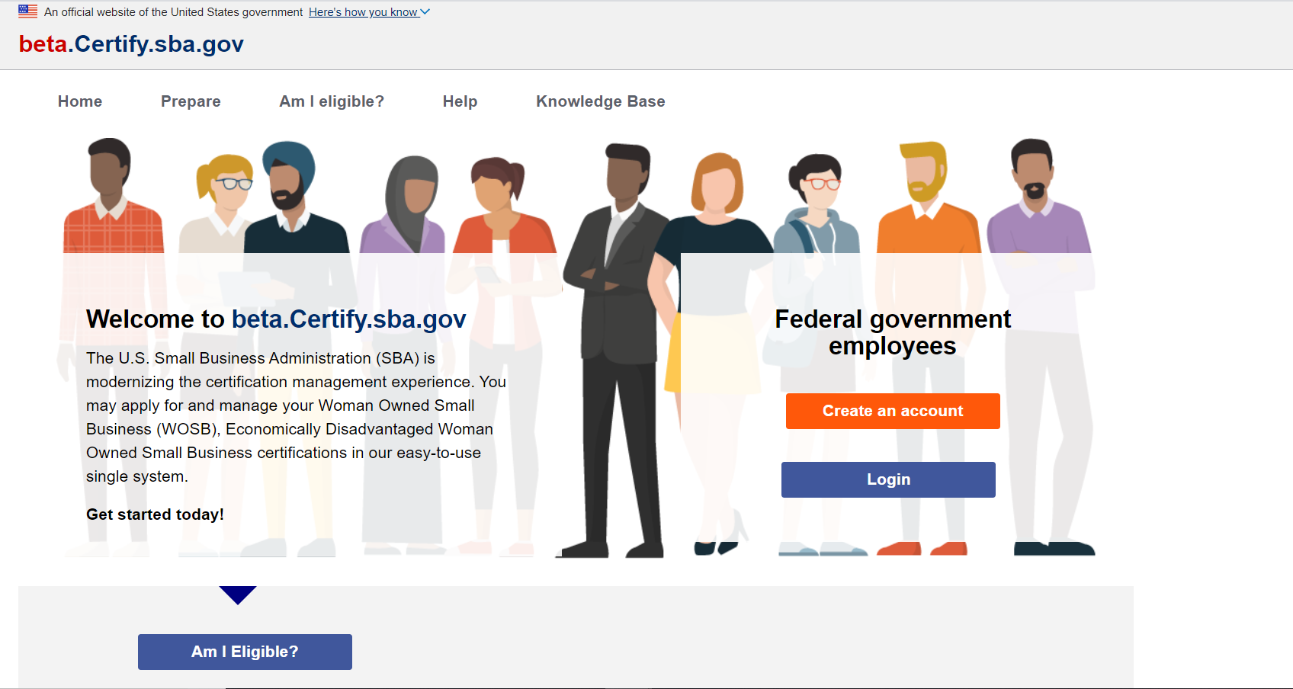

1. The users should be redirected to Connect/Login.gov for authentication when they login from D365 portal



### 2.11 SBA Connect SC-DLAP (Test Environment)

### Scenario: External users (IAL1) should able to verify his/her IAL2 information

1. When user click login on DLAP Home page, users should be redirected to Connect/Login.gov for authentication when they login from DLAP.

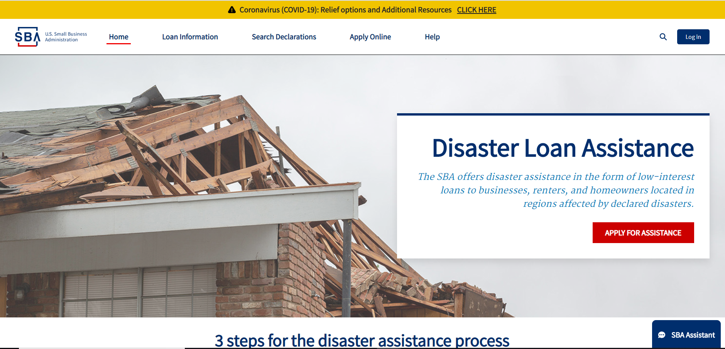

1. When user click the login page on DLAP home page user will be navigate to the login.gov “Term and Conditions” page,

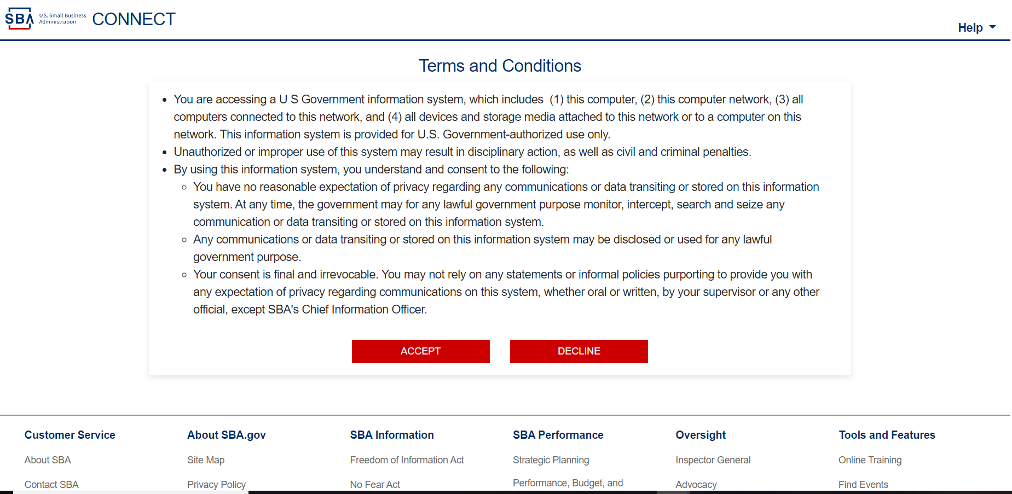

1. When user click “Accept” button, user will be navigate to the credential page

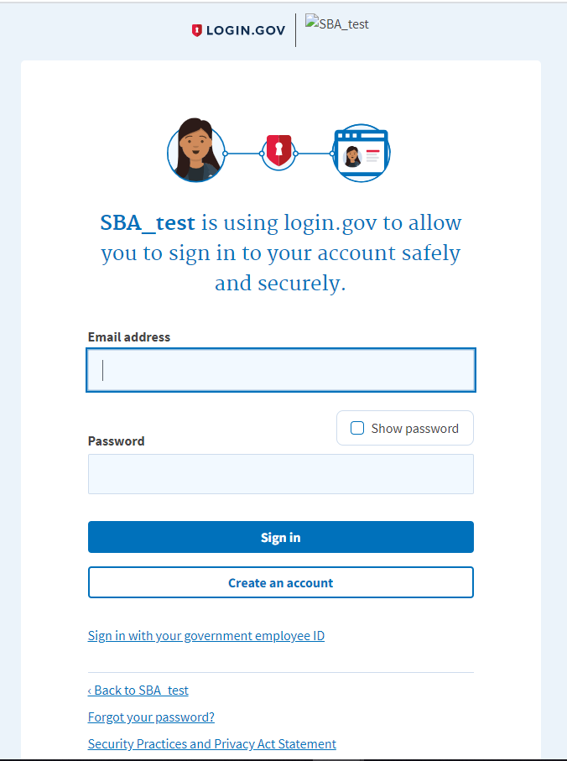

1. When user enter valid credentials and click sign in, user will be redirected to the IAL2 Identity verify page.

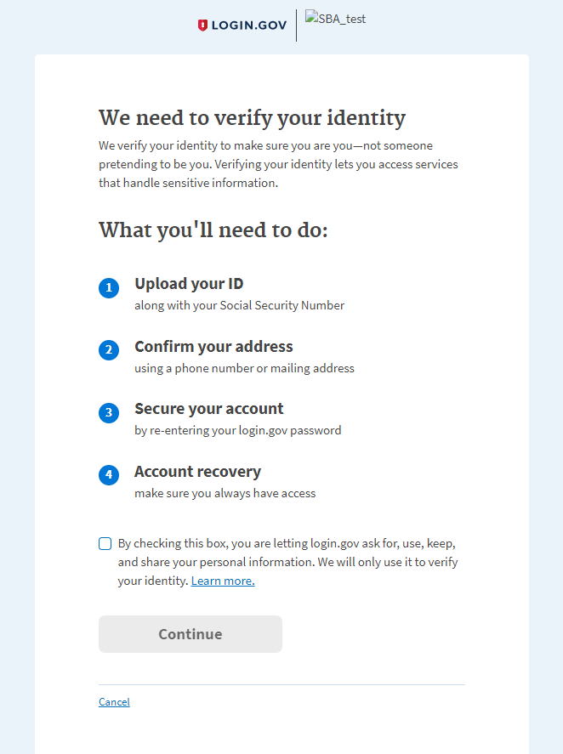

1. When user check the checkbox and click “Continue” button, user will be navigate to the Upload ID page

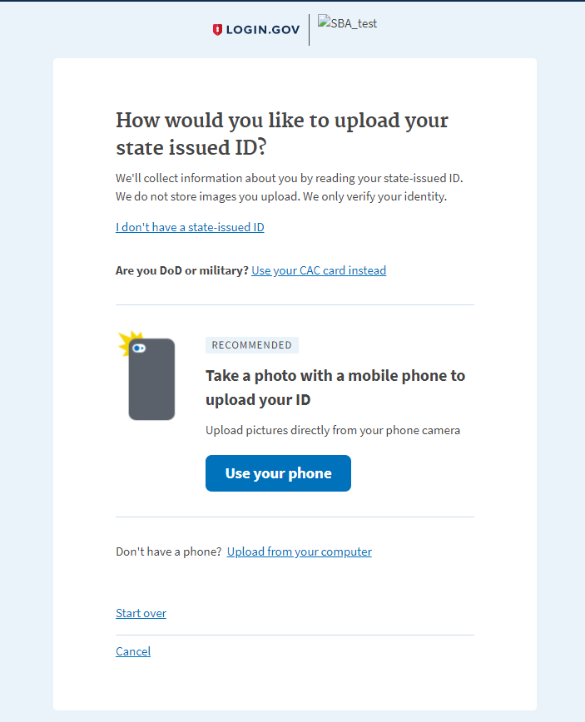

1. When user click “Upload from your computer” link, user will be navigated to the Upload front of ID page.

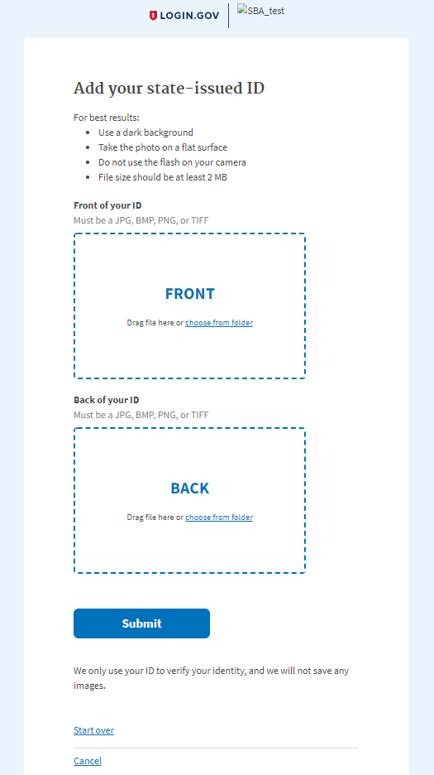

1. When user click choose file button, and upload front and back of ID, then click ‘Submit’ button system will navigate user to the SSN entry page.

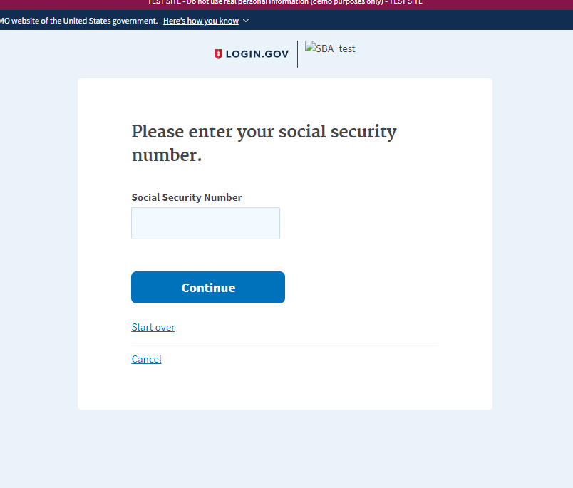

1. When user enter wrong SSN number click “Continue”, system will navigate to the Verify Information page.

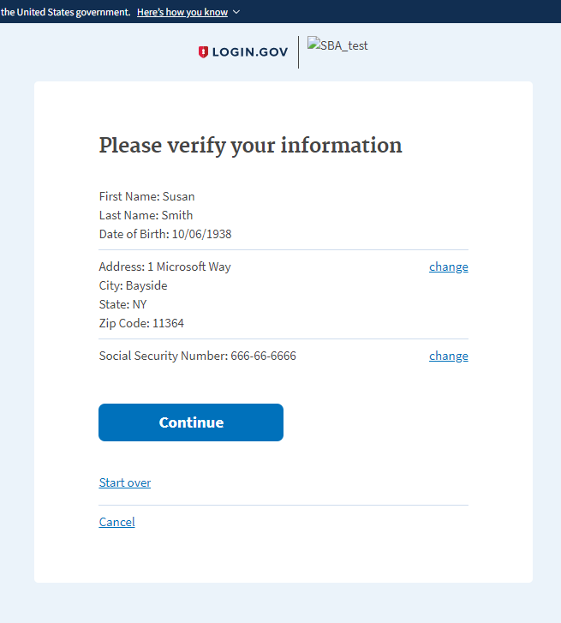

1. When user click “Continue” user will get warning message.

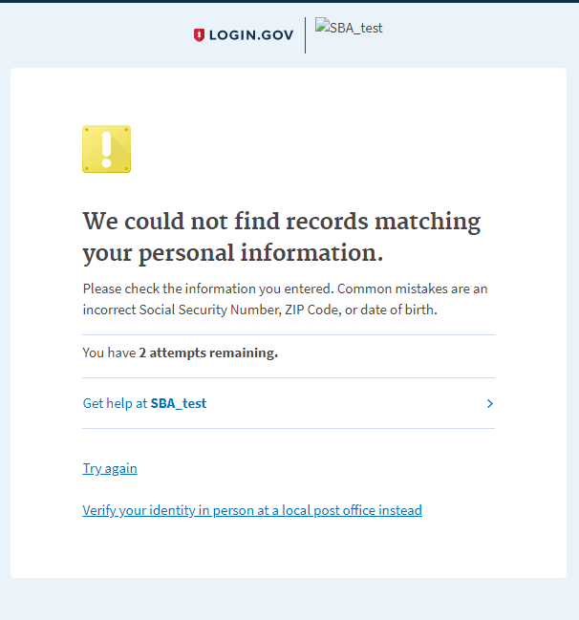

1. After user click try again, system will be navigate back to the SSN entry page.

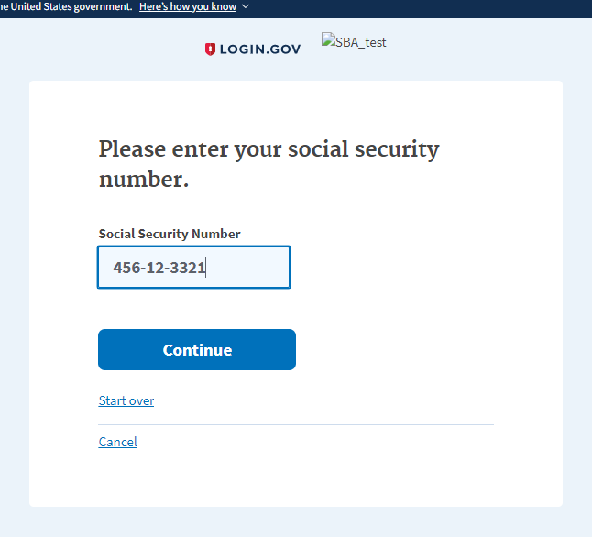

1. After enter valid SSN, the system will navigate to the verify information page again.

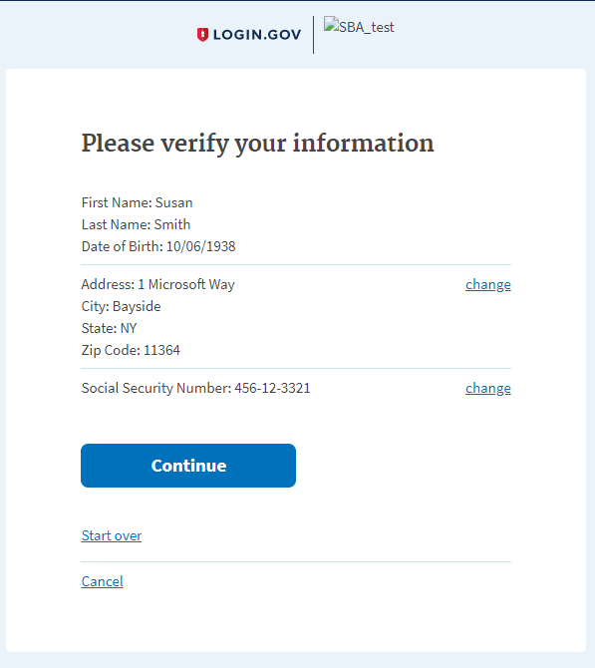

1. When user clicks the “Continue” button, system will redirect user to ID verification page.

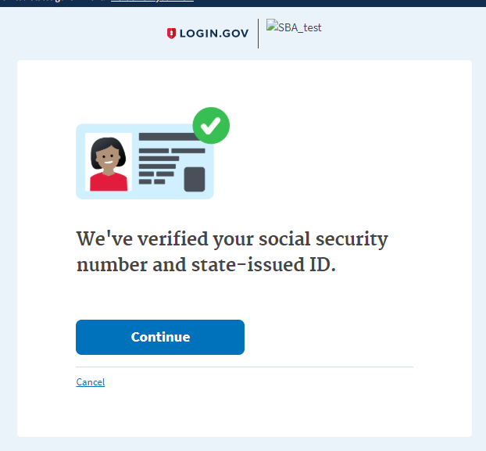

1. When user clicks continue the system will navigate user to the phone verifying page.

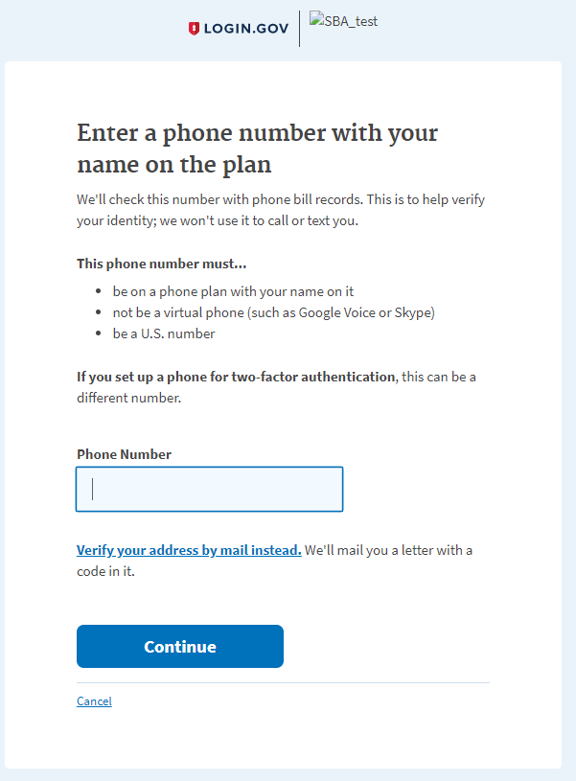

1. When user enter wrong phone number, user will get warning message.

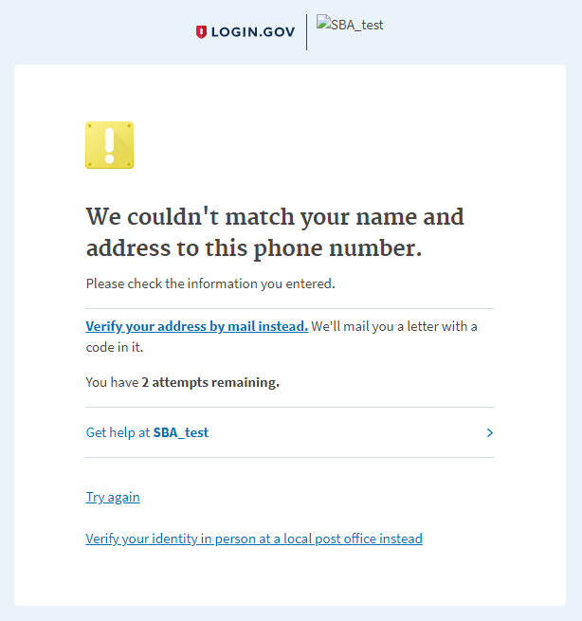

1. After enter correct phone number and continue, system will navigate the user to reenter password page.

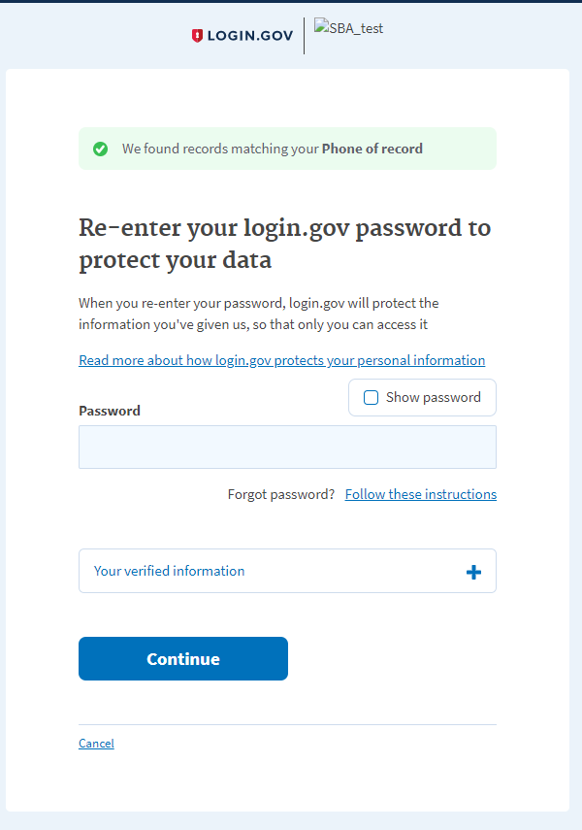

1. After user enter valid password, system will navigates the user to personal key page.

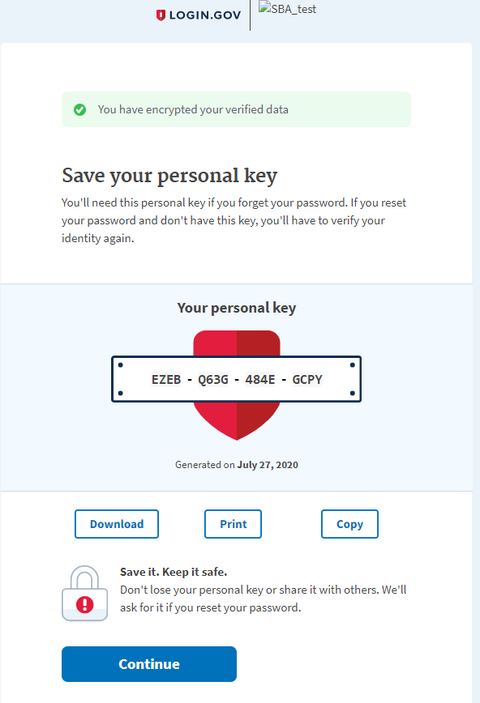

1. After copy personal key and click continue button, system will navigates the user to enter personal key page.

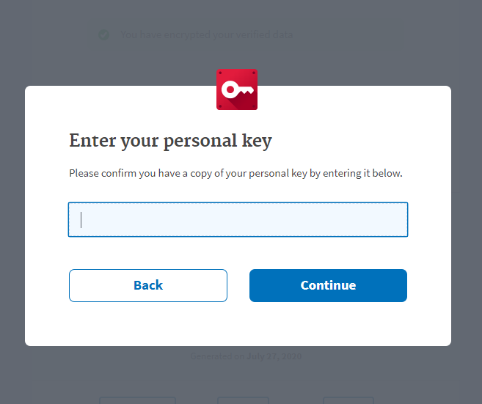

1. When user paste/enter the personal key and clicks the continue button, system will navigates the user to the identity verified/ Agree and continue page.

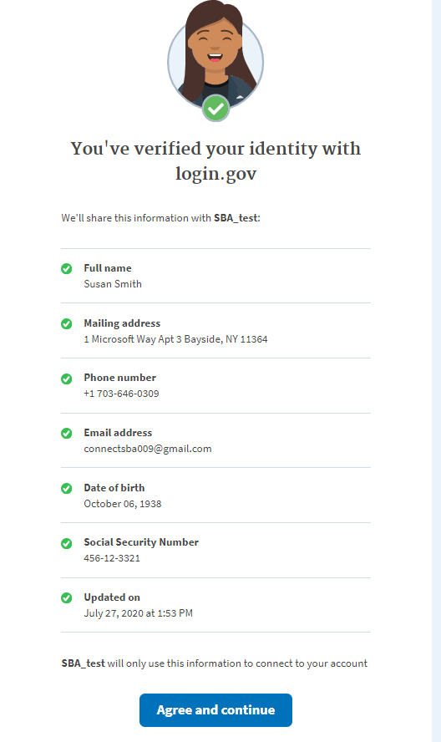

1. When user click agree and continue, system will navigate the user to the DLAP home page.

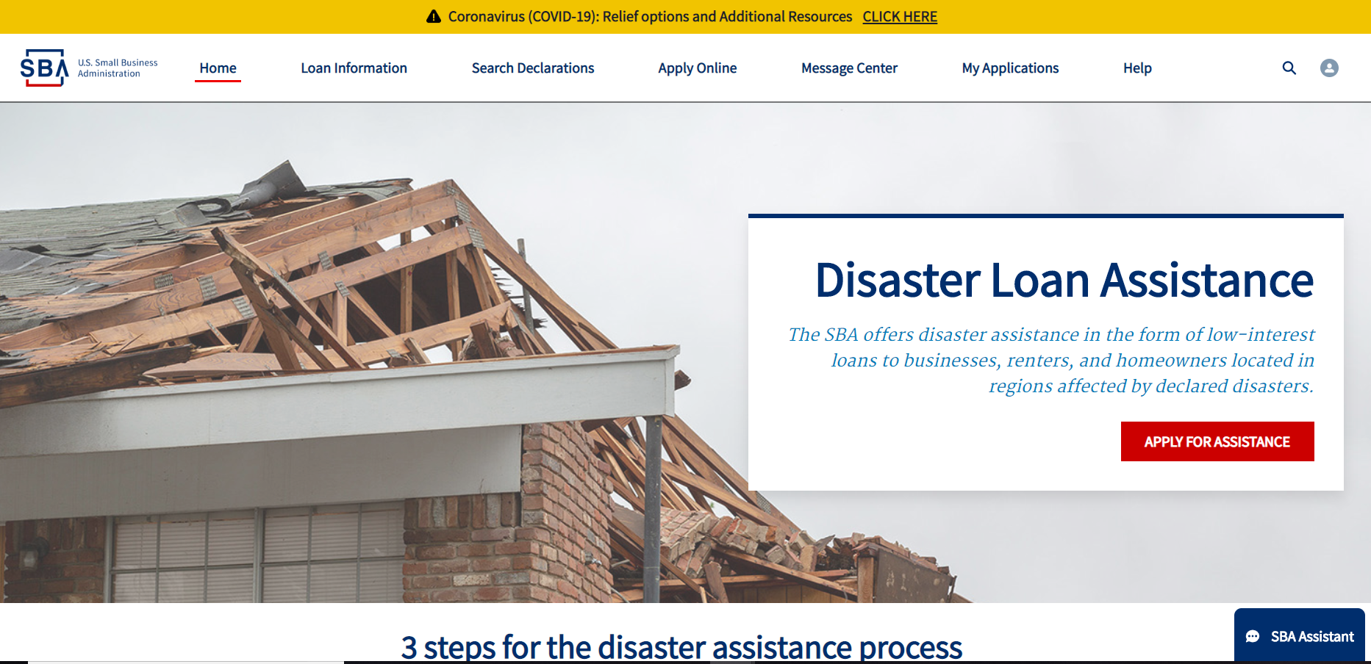

### 3.11 SBA Connect SC

**Scenario: New User login from SBA Connect to DLAP application (positive)**

1. Given user on the SBA Connect login.

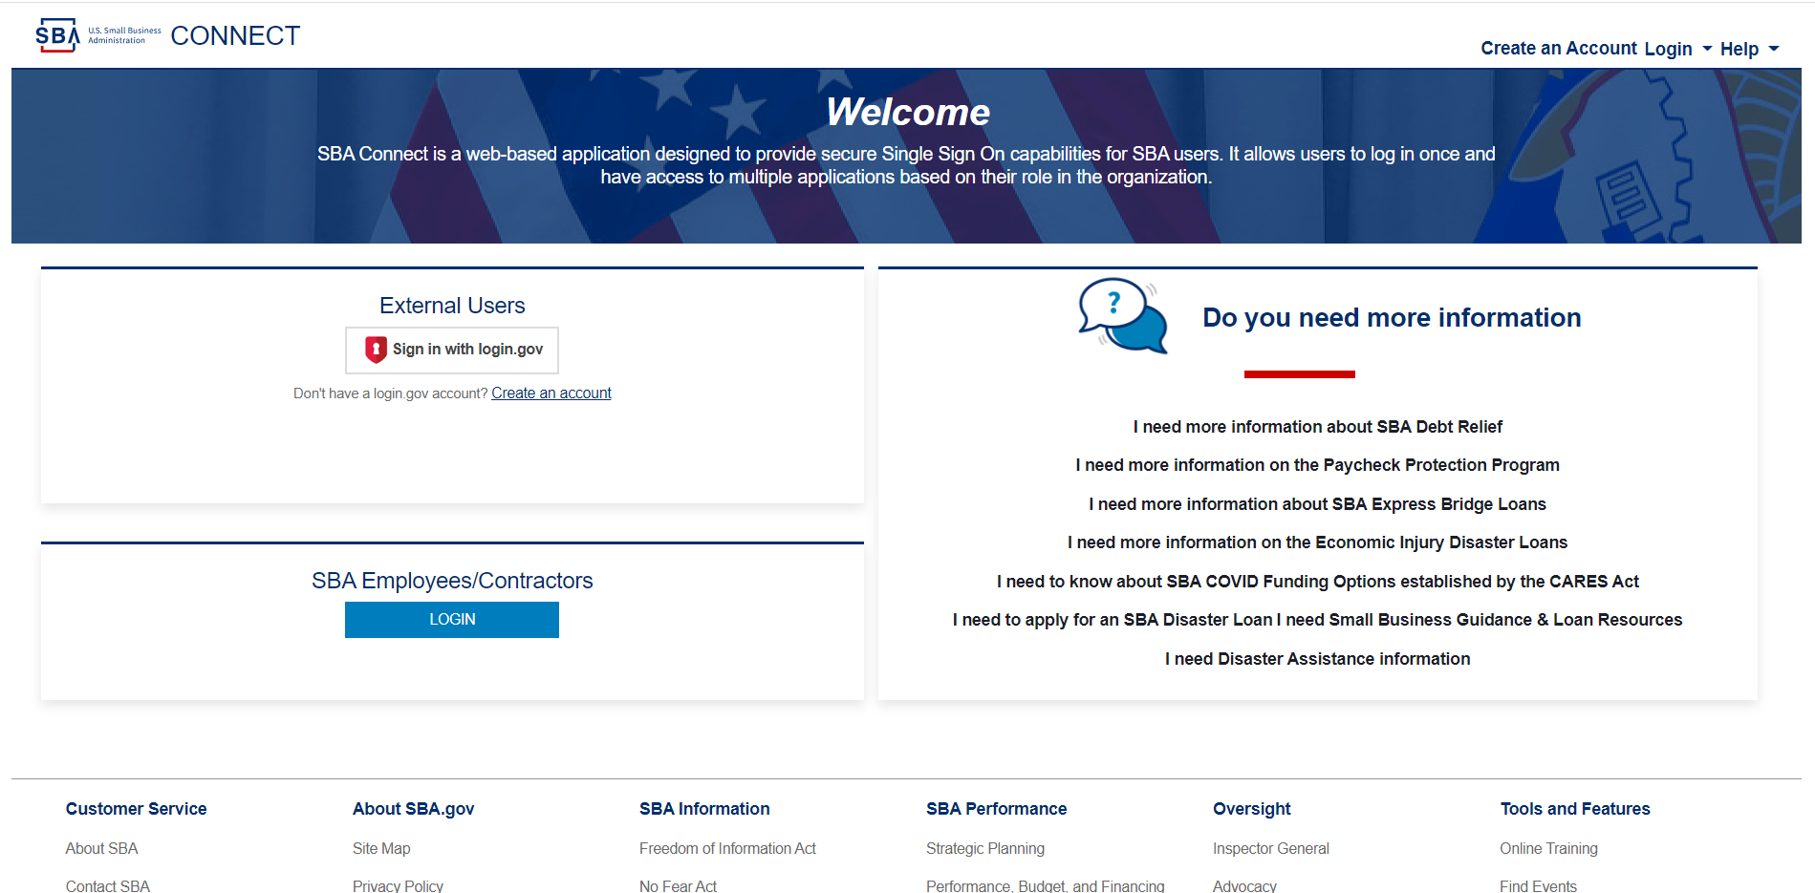

1. When user clicks the ‘Create an account’ the system navigates the user to the ‘Terms and Conditions’ Page.

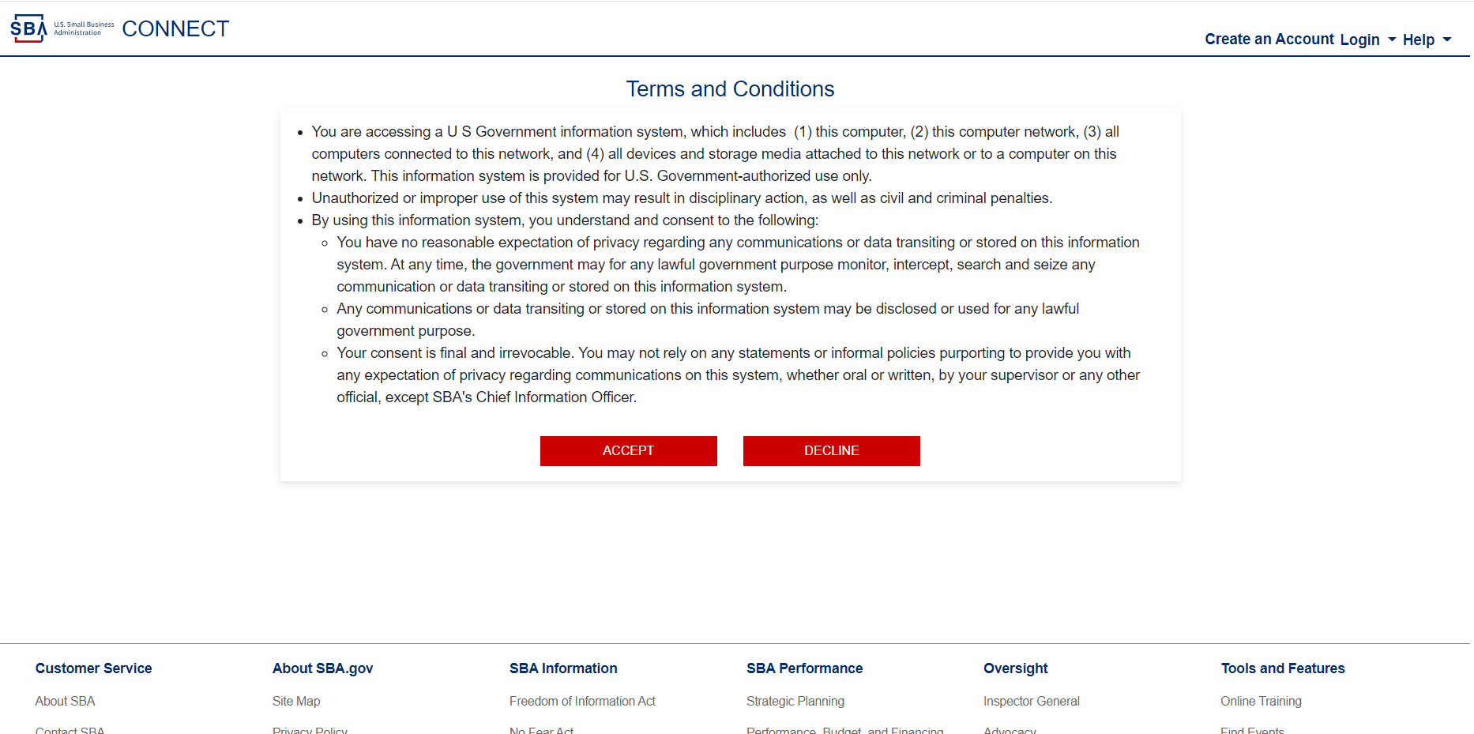

1. When user clicks the ‘Accept’ button, the system will navigates the user to credentials page (login.gov – Welcome).

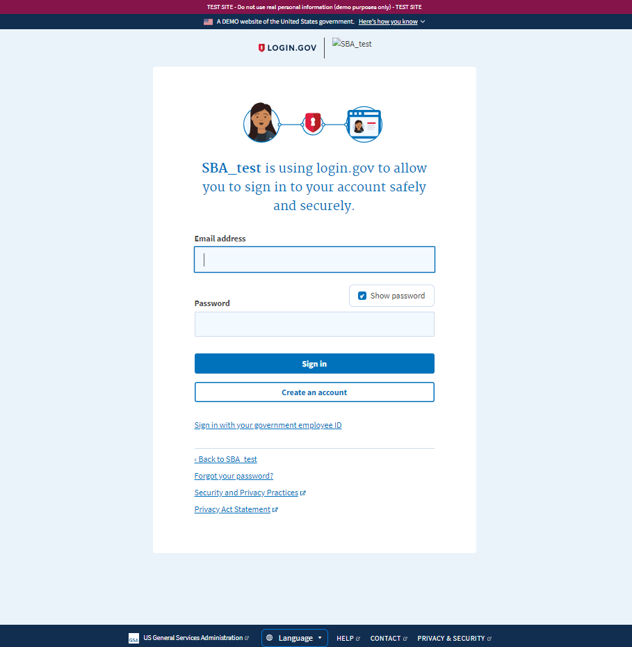

1. When user enters their email and click the ‘Create account’ button, the system will navigates the user to the Email address page.

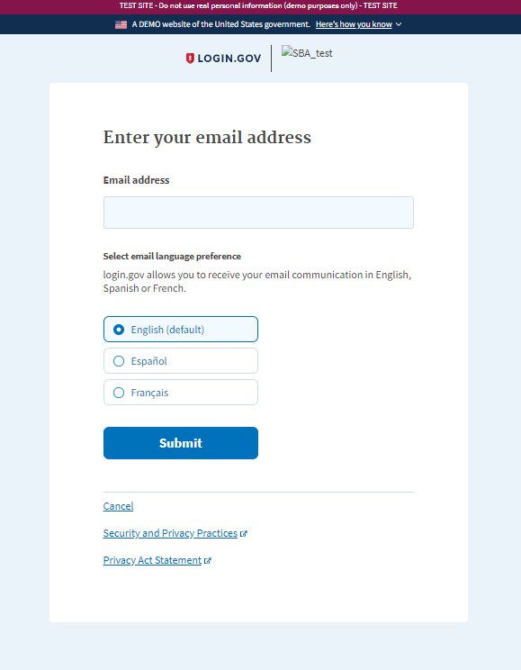

1. When user enters the email and click submit, the system will navigates the user to check your email page.

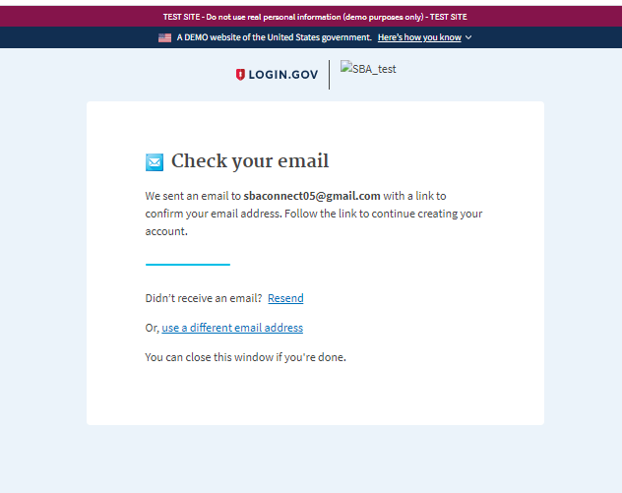

1. When user login and click the link ‘Confirm email address’, the system navigates the user to the ‘Create a strong password’ page.

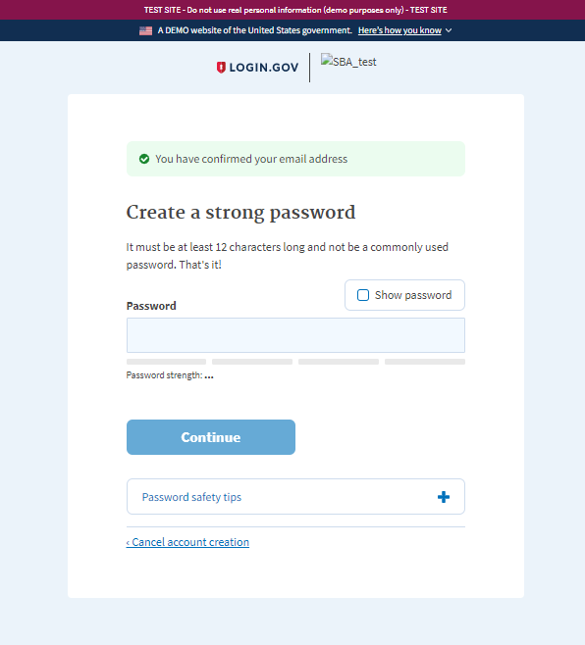

1. When user enters a valid password and clicks ‘Continue’, the system will navigates the user to the ‘Authentication method setup’ page

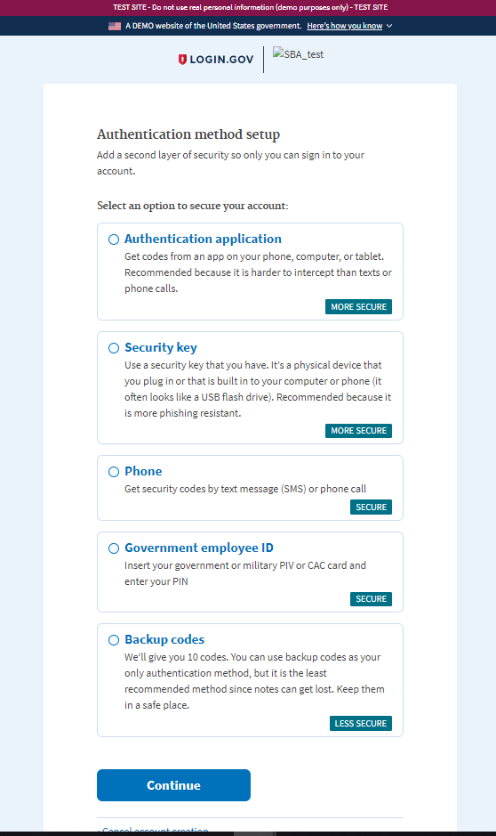

1. When user chose ‘phone’ and clicks ‘Continue’ the system will navigates the user to Phone number page.

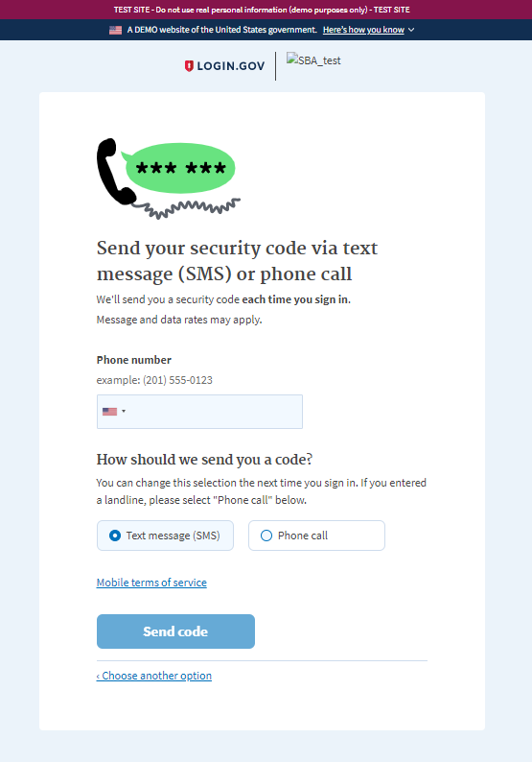

1. When user enter their phone and clicks ‘Send code’ button the system will sent to user one time OPT message.

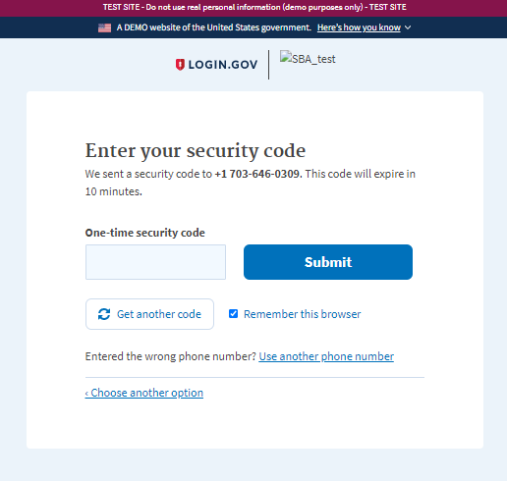

1. When user enter OTP code (one time security code0, and click ‘Submit’ the system will navigates user to ‘Agree and continue’ screen.

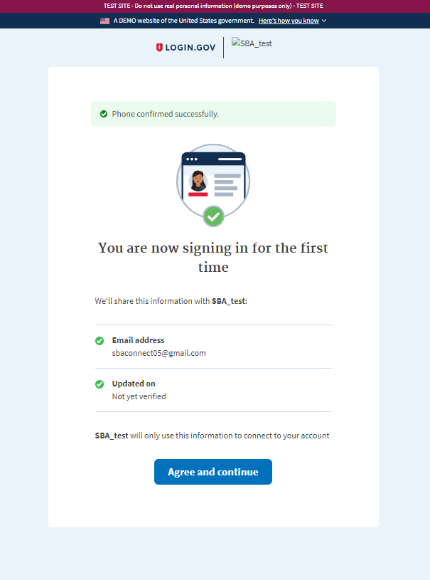

1. When user click ‘Agree and continue’ the system will navigates the user to the ‘Profile information’ page.

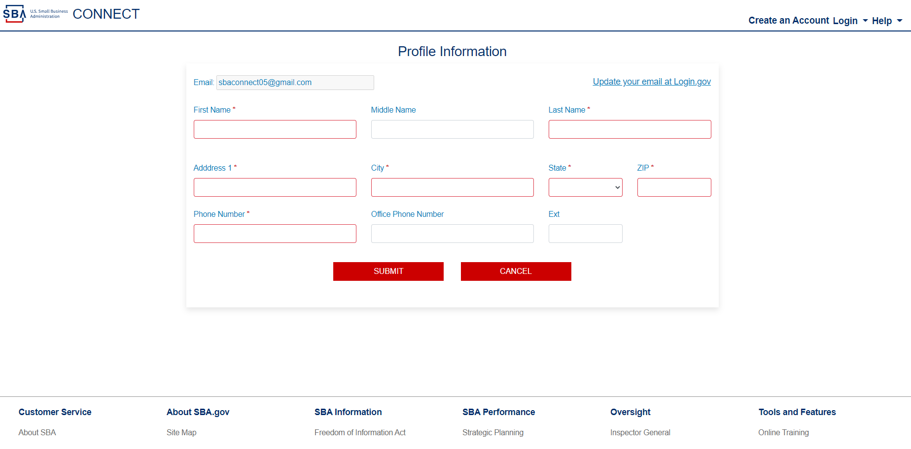

1. When user fill the information and click submit, will see ‘Success!’ popup

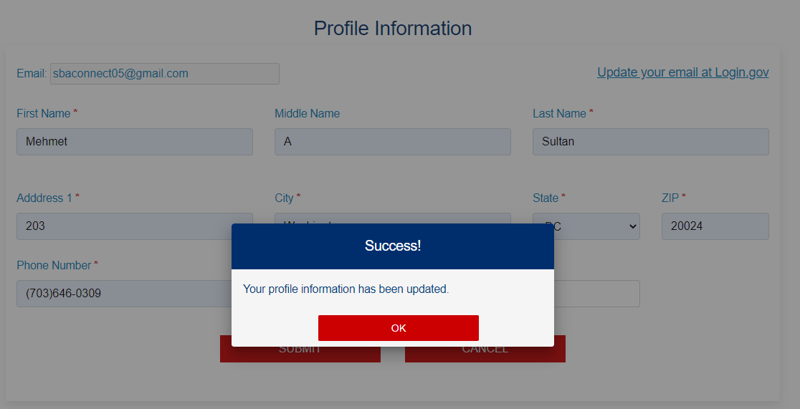

1. When user click Ok, will navigates to SBA connect home page

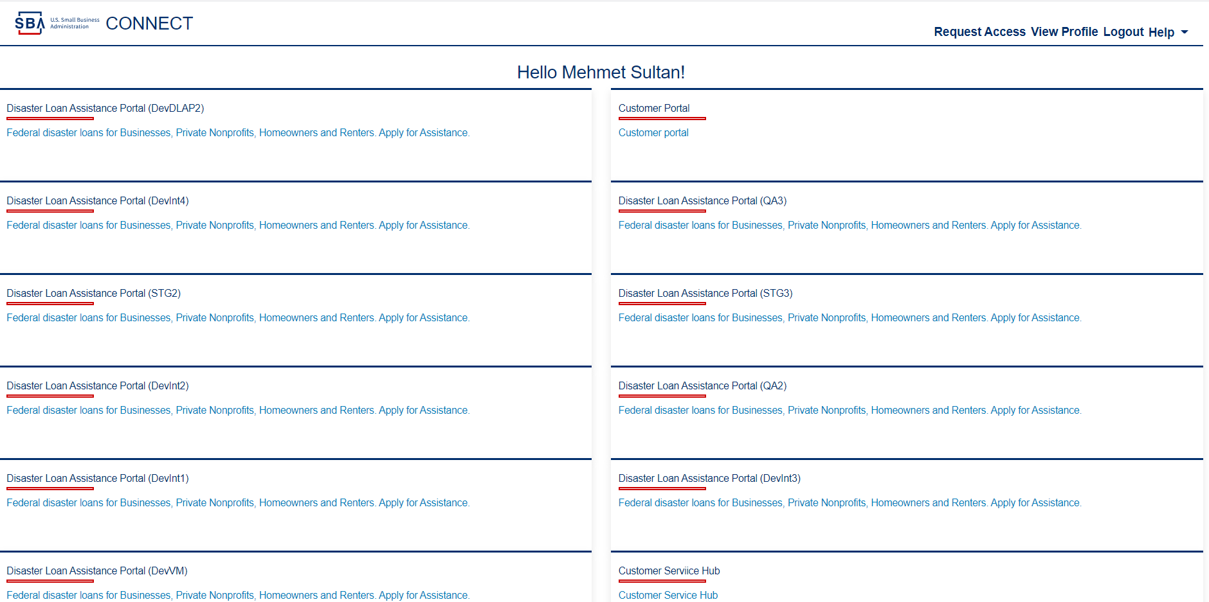

1. When user click DLAP link on the SBA Connect home page, user will navigates to ‘Verify your identity’ page.

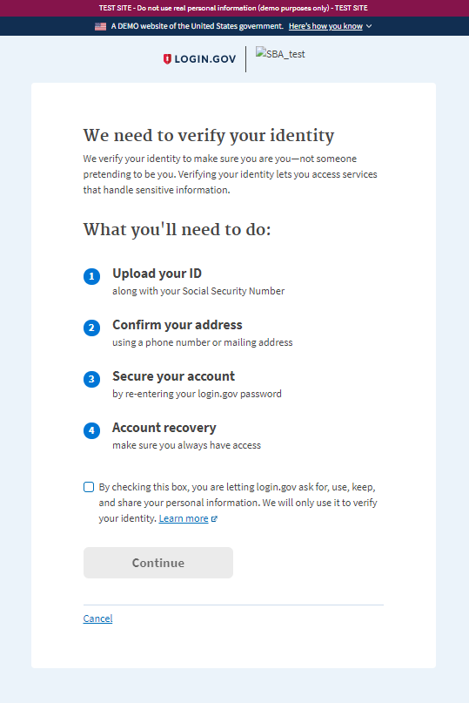

1. When user check the checkbox and click the ‘Continue’ button, will navigate ‘upload ID’ page.

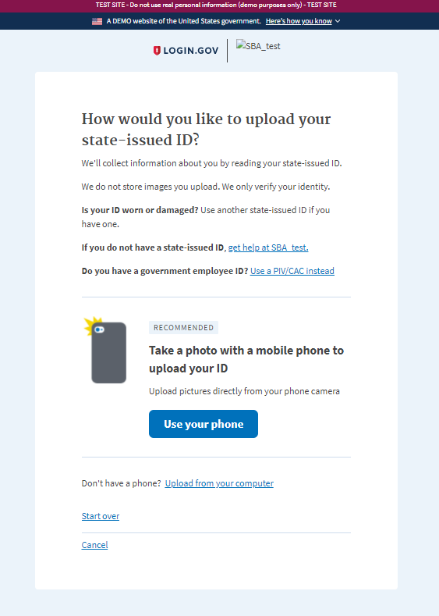

1. When user click ‘Upload from computer’ will navigate ‘Add your state-issued ID’ screen.



1. When user upload their ID’s front & back and submit, user will navigates to ‘Enter SSN’ screen.

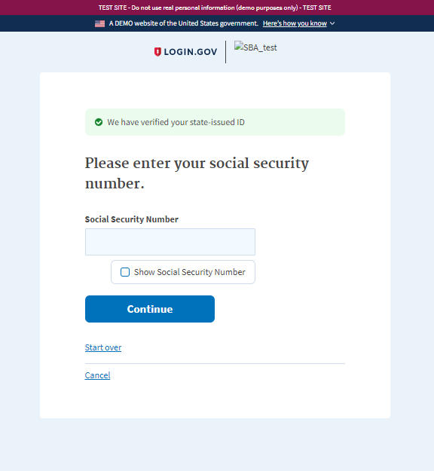

1. When user enter SSN and click ‘Continue’, user will be navigates to the’ Verify your information’ screen.

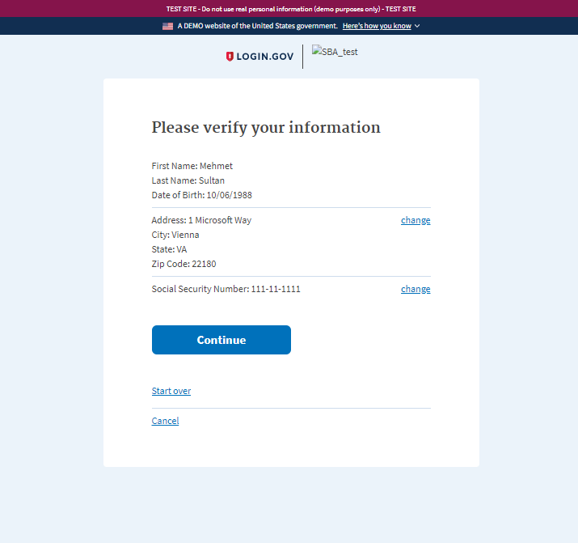

1. When user verify and click continue, user will be navigates to ‘Enter phone’ screen.

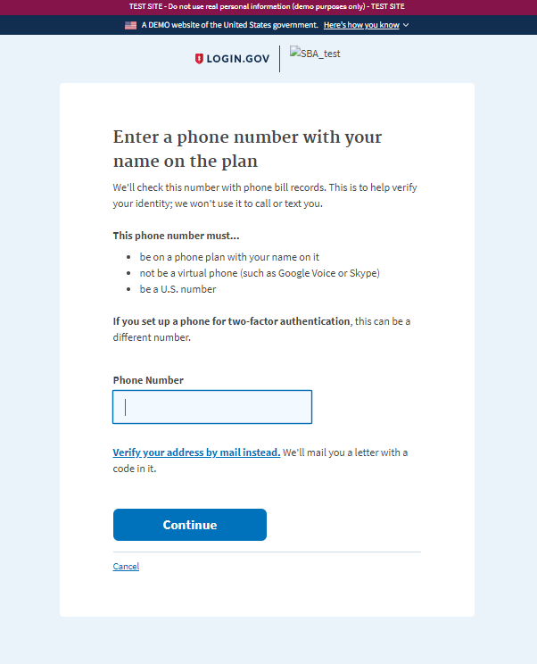

1. When user enters the phone number and click ‘Continue’, user will be navigates to enter ‘Password’ screen.

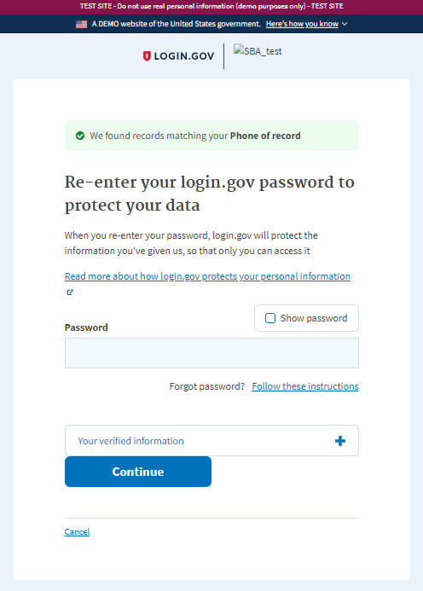

1. When user re-enter the password click ‘Continue’ user will be navigates to ‘You’re your personal key’ screen.

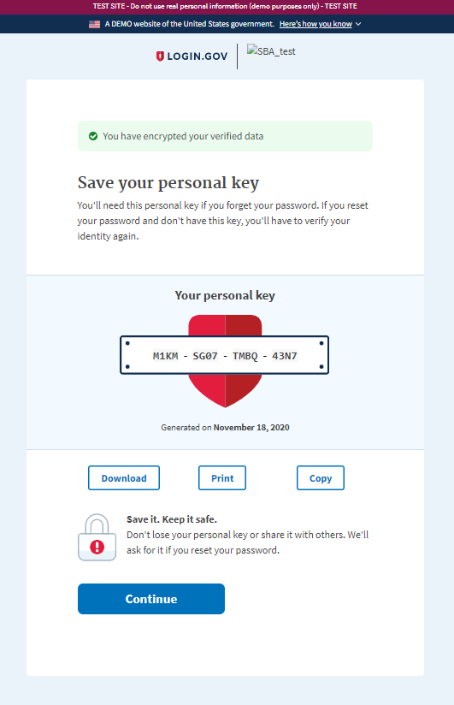

1. When user copy the personal key and continue, user will be navigates to ‘Enter personal key’ screen.

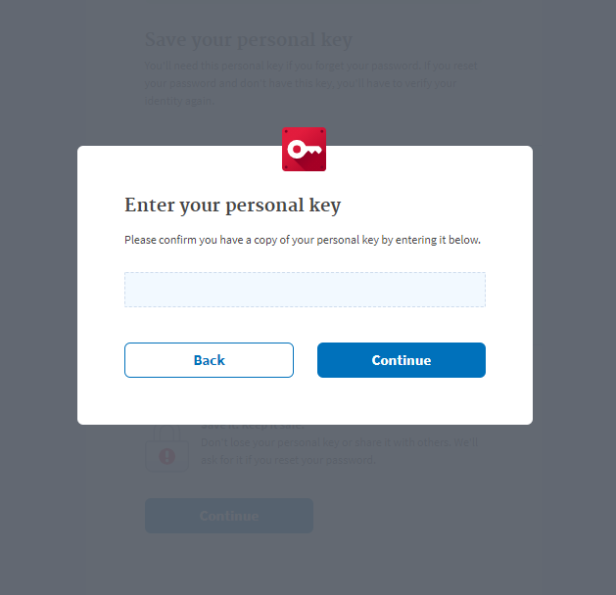

1. When user enter the personal key and continue, user will be navigates to the to ‘Agree and continue’ page.

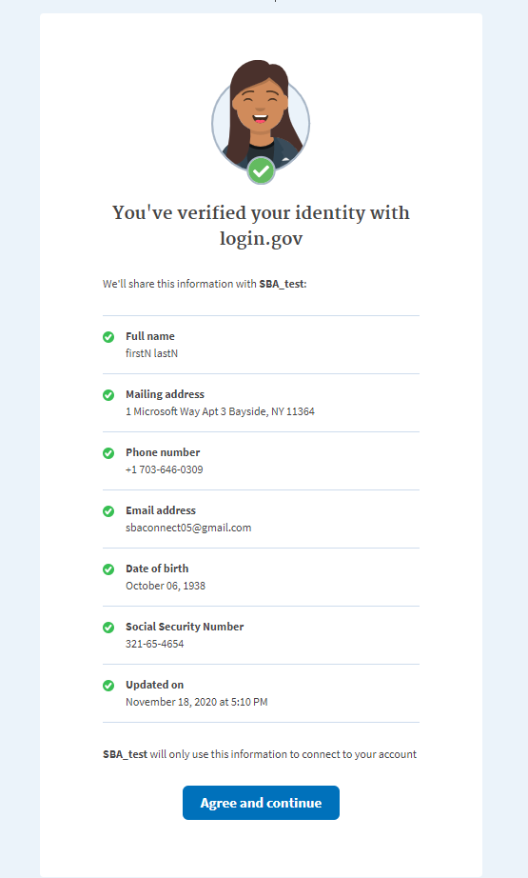

1. When user click ‘Agree and continue’ button, user will be navigates to the IAL 2 verified page with information.

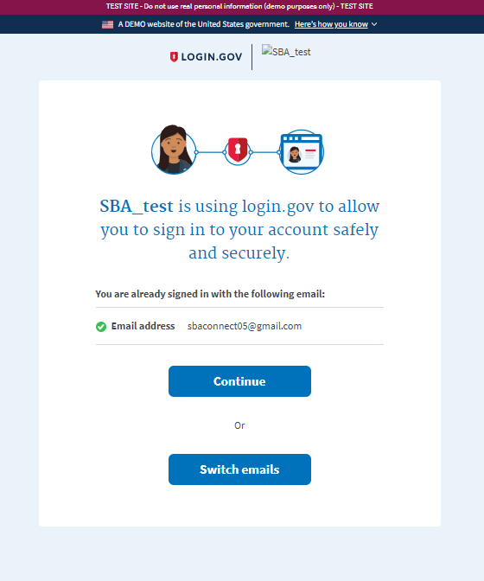

1. When user clicks ‘Continue’ user will be navigates to DLAP home page.

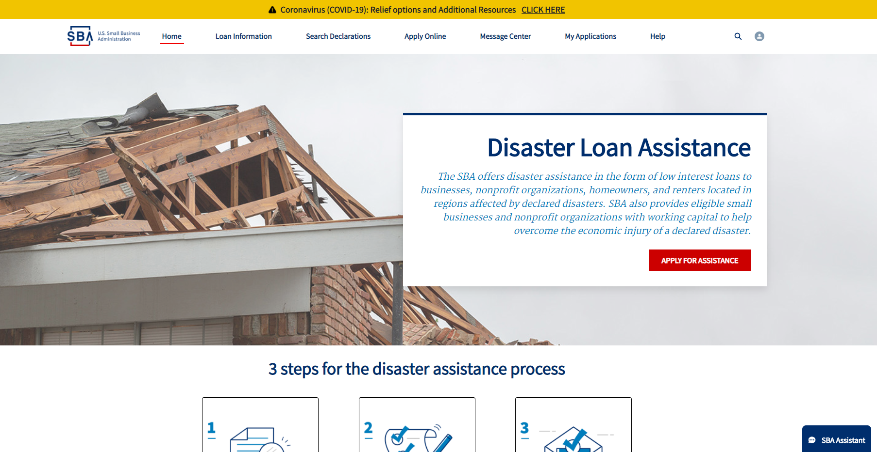

1. When user check the profile information page on the SBA Connect, the ‘Personal Information’ page is not editable.

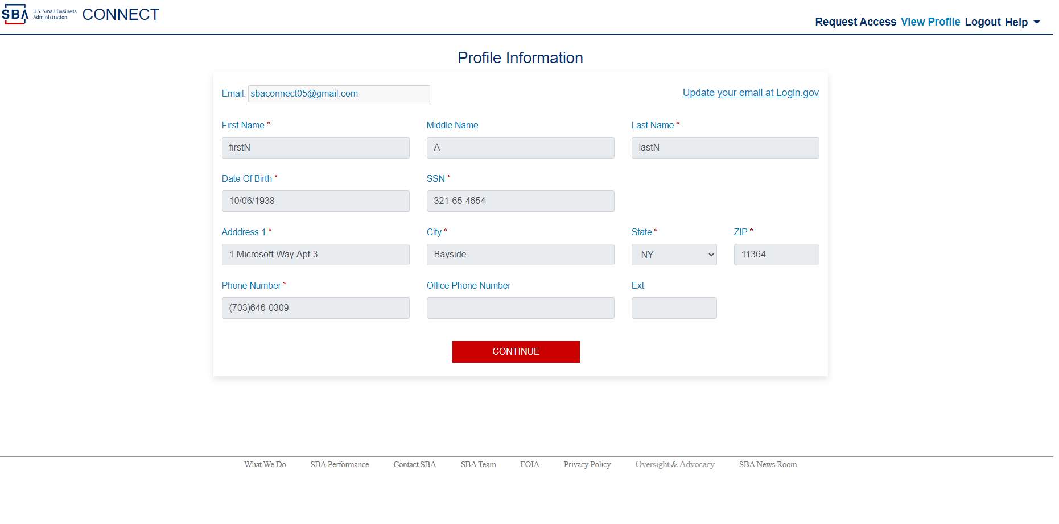

### 9.11 SBAConnectSC

### Scenario: User Request SBIC-Web Role

1. When user on the access manager page, click SBIC Web application card, the SBIC Web application will be expand and roles are appears

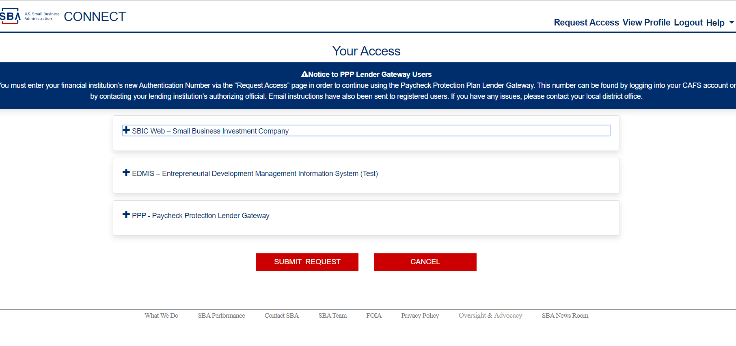

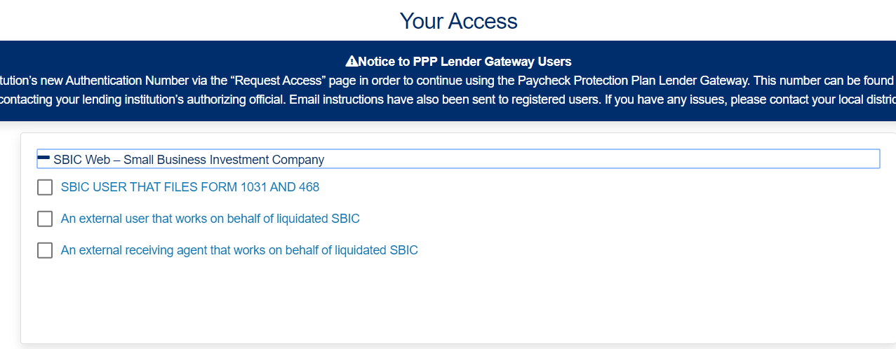

1. When user select one of the checkbox, the checkbox will be selected and the pop up message will be appears with the message “Confirm Access Change” and “YES” and “NO” buttons.

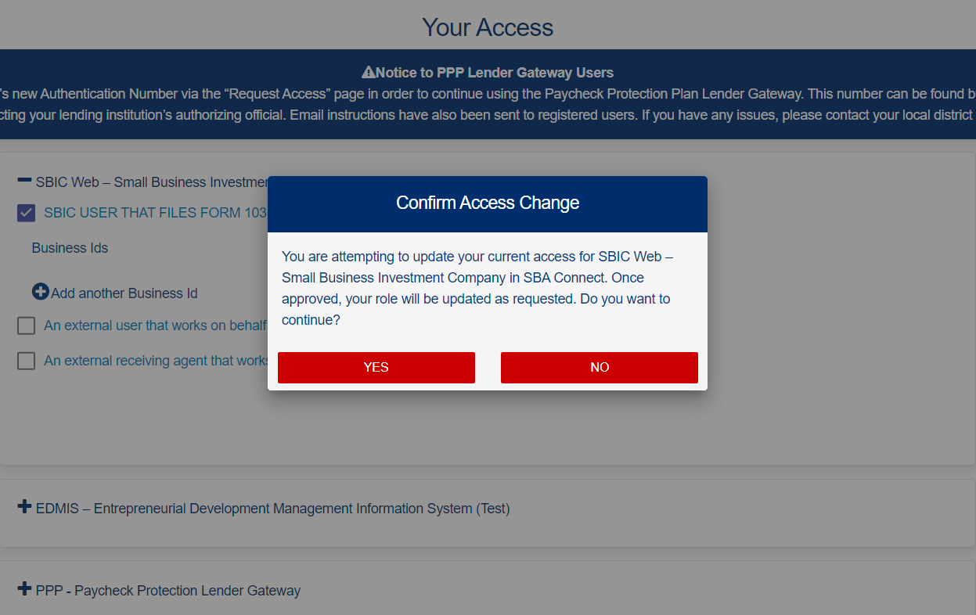

1. When user click the “YES” the text box for the Business Ids is appears

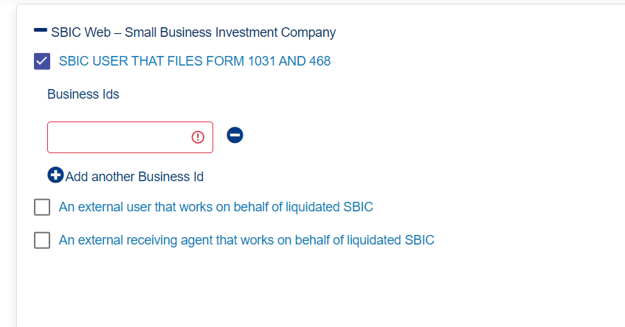

1. When user enter valid Ids/EIN the financial institutions name will be appears in green color.

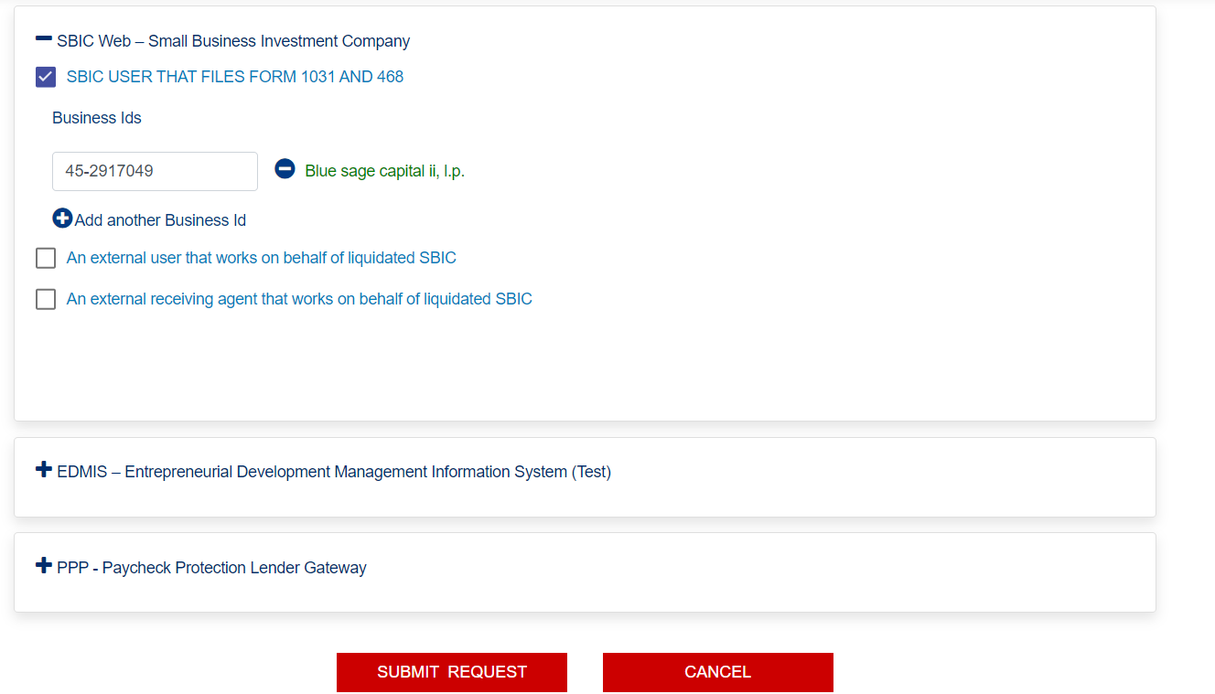

1. When user click “Submit Request” the success messages will be appears.

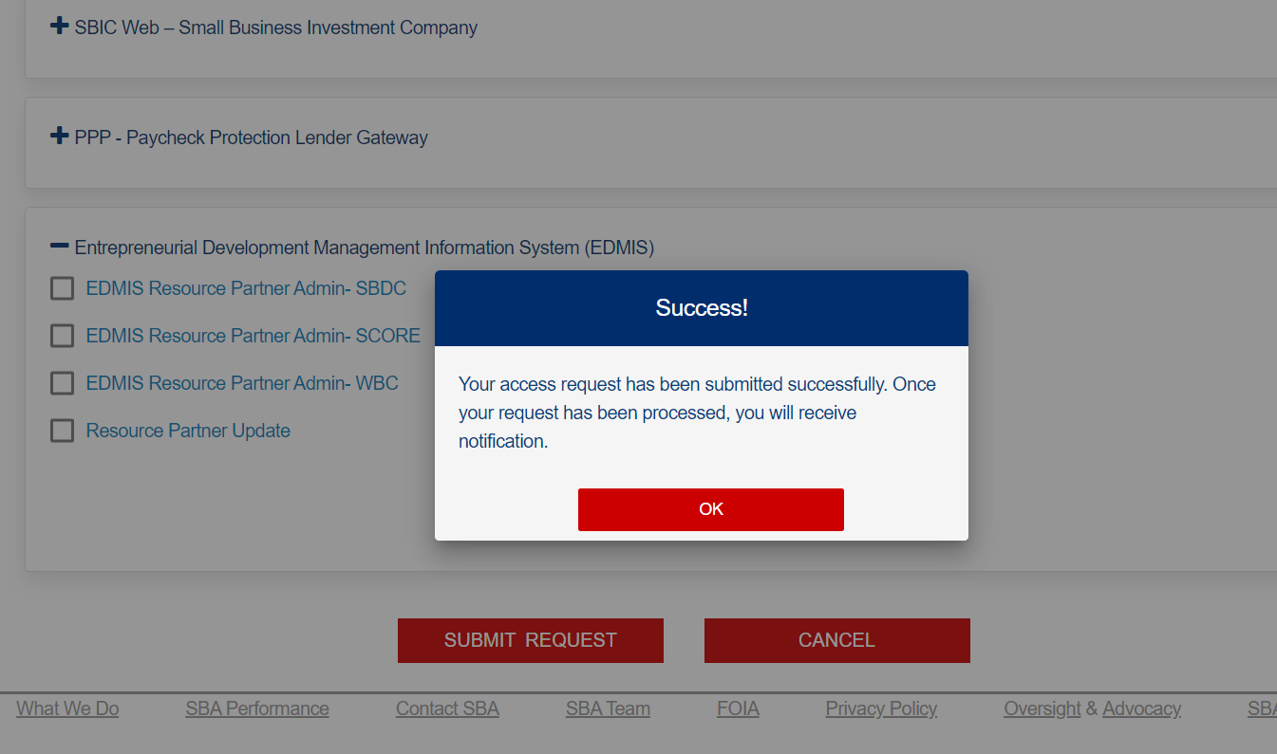

1. When user click the “Ok” the system will navigate back the user to “Access Manager” page.

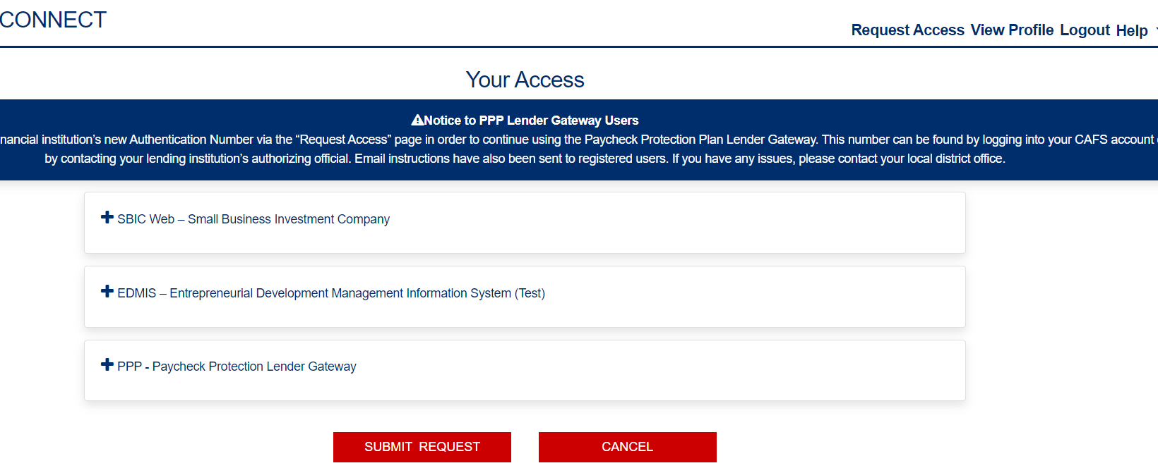

### 9.12 SBAConnectSC

### Scenario: User Request PPP Role

1. When user click PPP application card on Request Access page, the PPP card will expand the “Lender Request” checkbox will be appears.

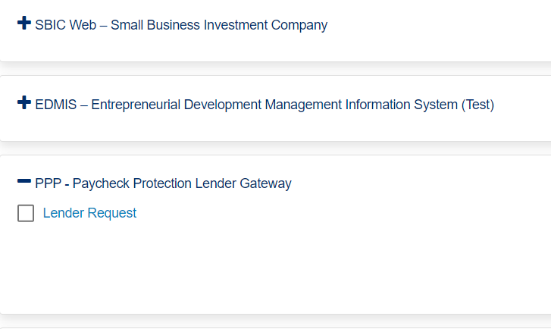

1. When user click the checkbox for “Lender Request”, the “Confirm Access Change” pop up message will be appears.

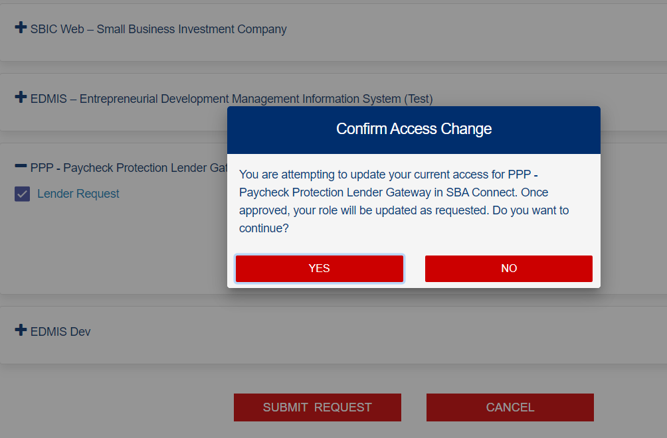

### 9.13 SBAConnectSC- Certify

**Scenario:** As a new User, I should be able to successfully login to Certify application thought SBA Connect

1. User is on the Home Page of the SBA Certify application.

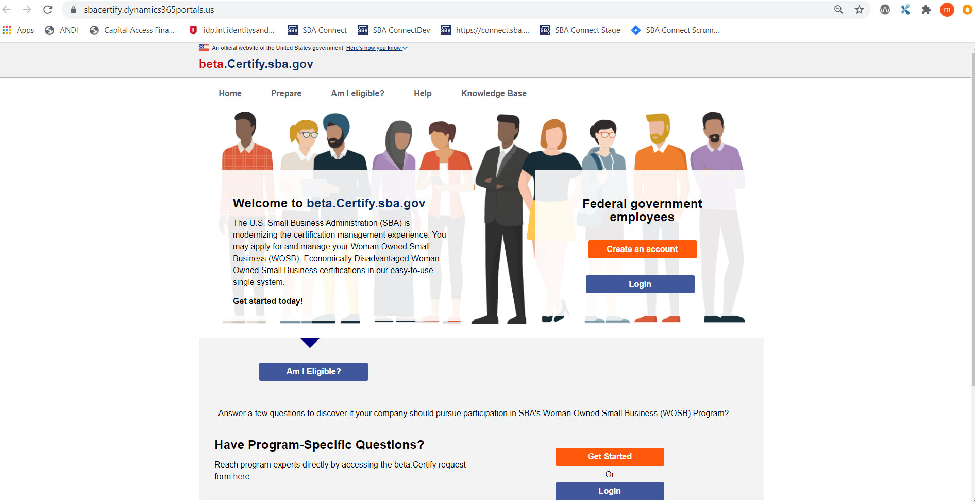

1. When user clicks on the login button (one on the bottom of the page), user will be navigated to the SBA Connect “Terms and Condition” Page.

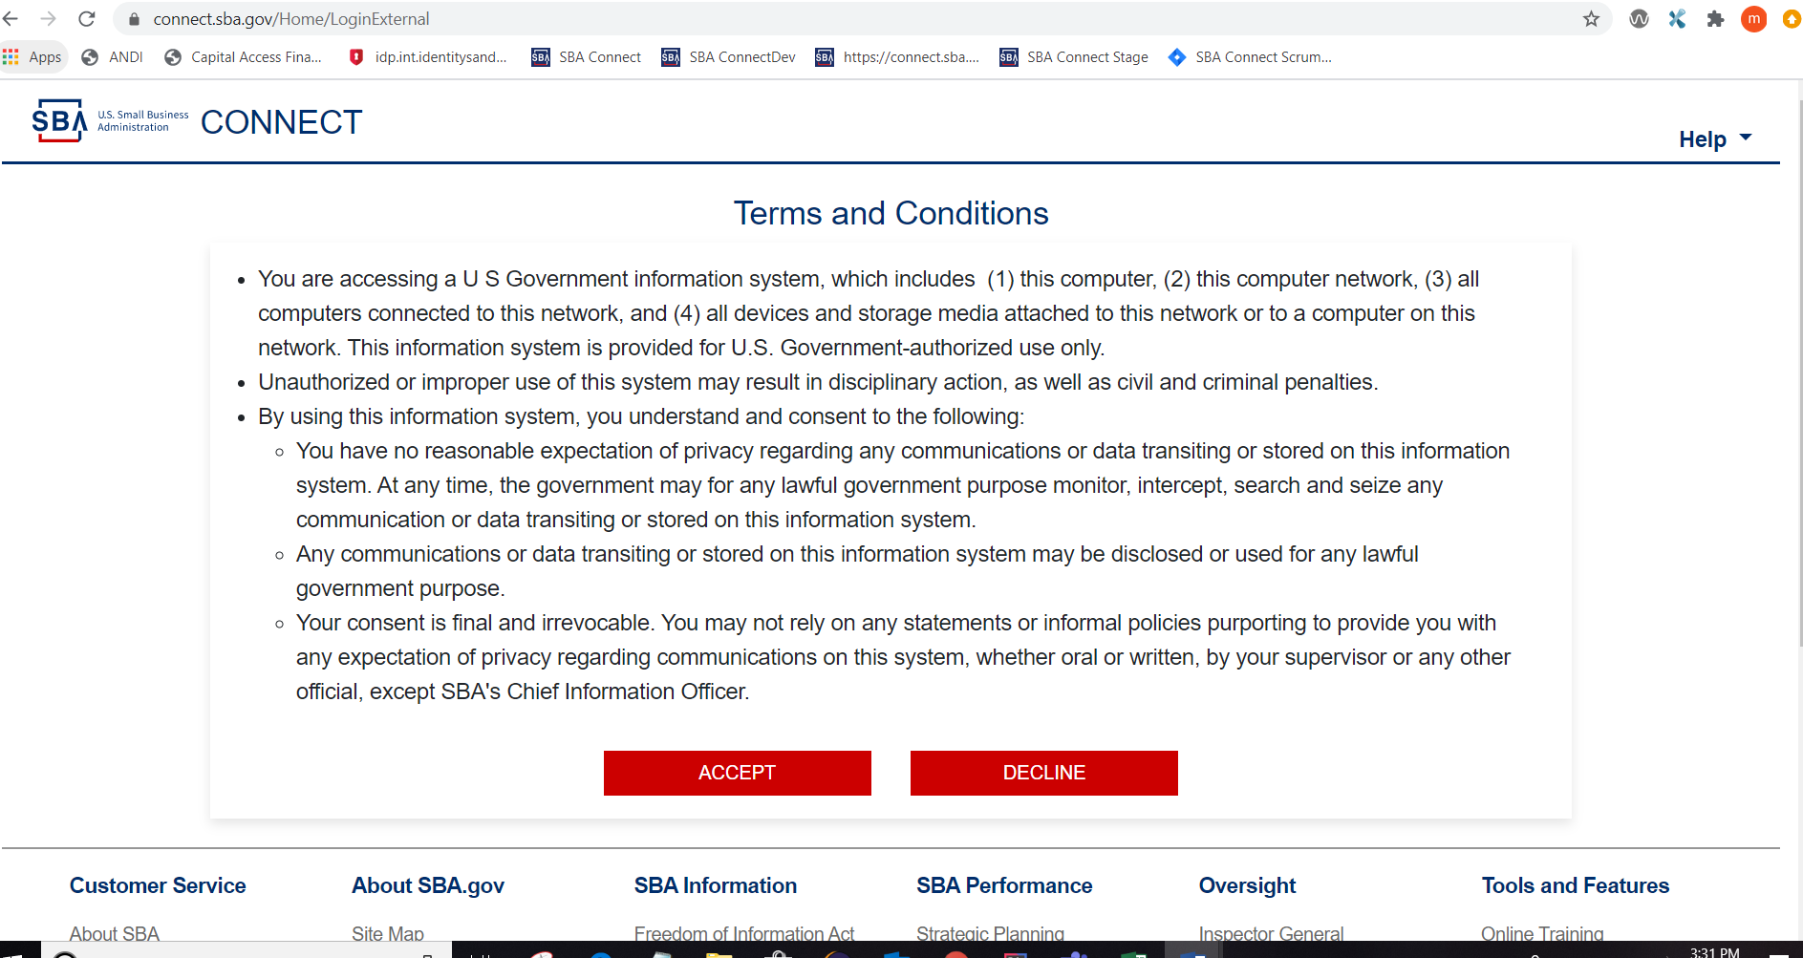

1. When user clicks “Accept” button, user will be navigated to credential entry page.

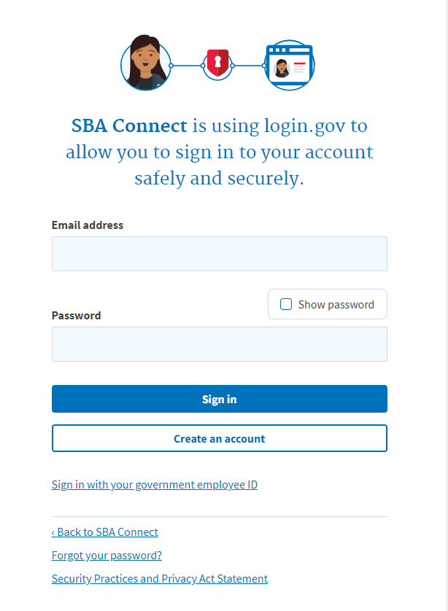

1. When user clicks the “Create an account” button, user will be navigated to email entry page.

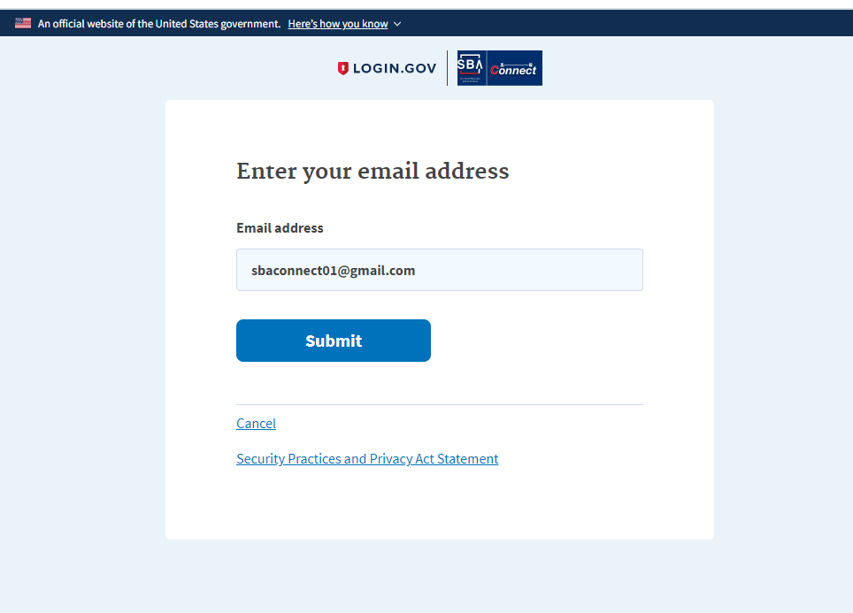

1. When user enters the email and submits, user will be navigated to the check your email page.

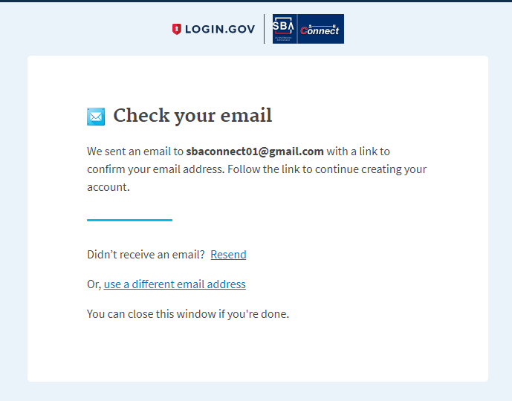

1. When user confirm the email address and clicks that link the system provided, user navigated to the Create password page.

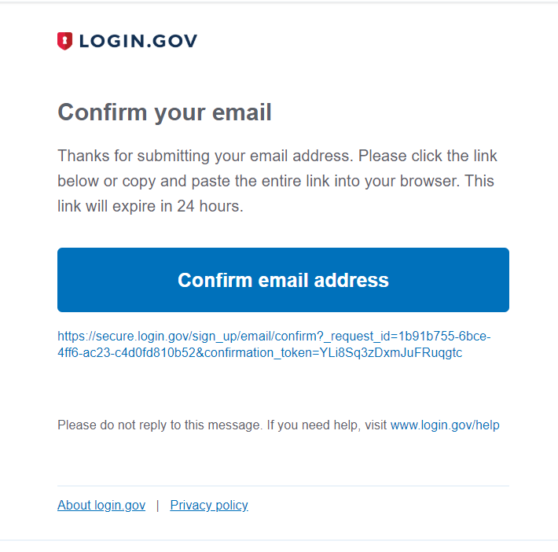

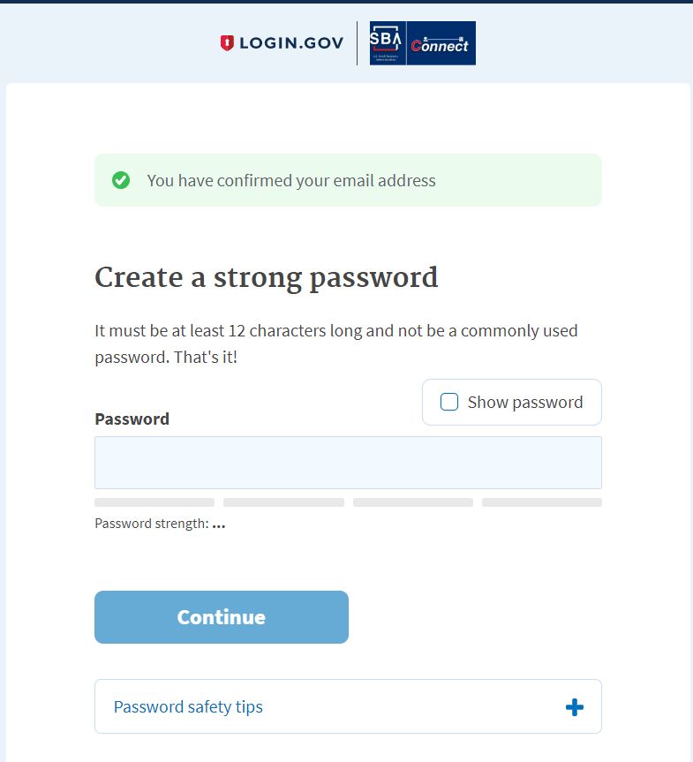

1. After user creates a valid password and clicks the Continue button, user will be navigated to authentication setup page.

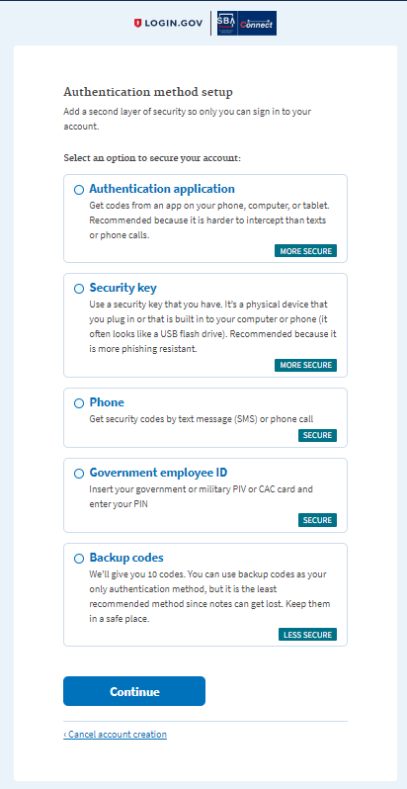

1. When user selects “Phone” Radio button and clicks “Continue”, it will navigated to Phone entry page.

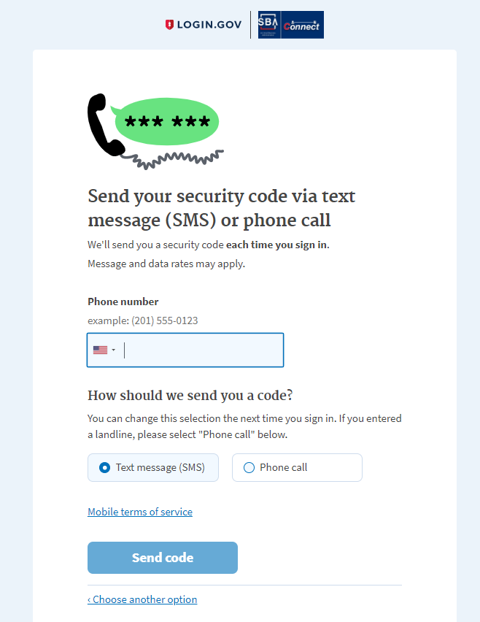

1. When user enters the phone number and clicks send code button, user will receive the one time pass code.

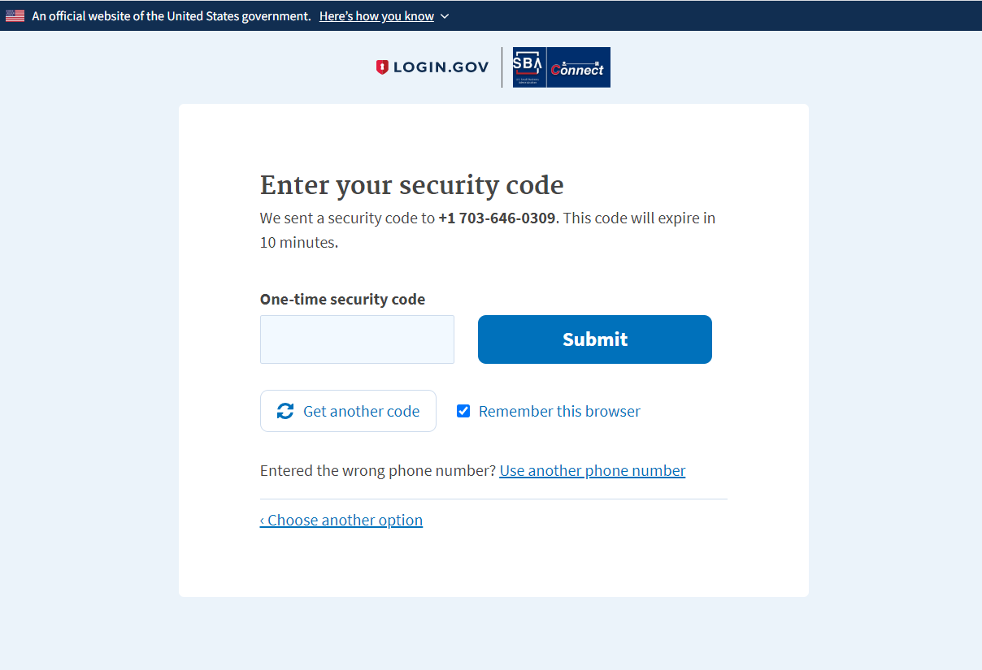

1. After user enters the one time code, and click Submit button, user will be navigated to the page “Phone confirm successfully” page

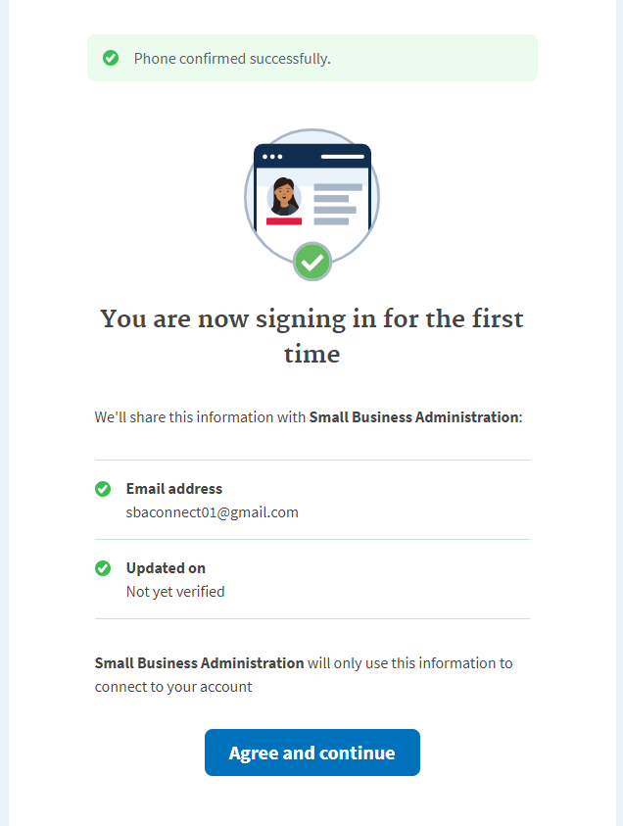

1. When user clicks “Agree and continue” button, user will be navigated to SBA Connect Profile Information” page.

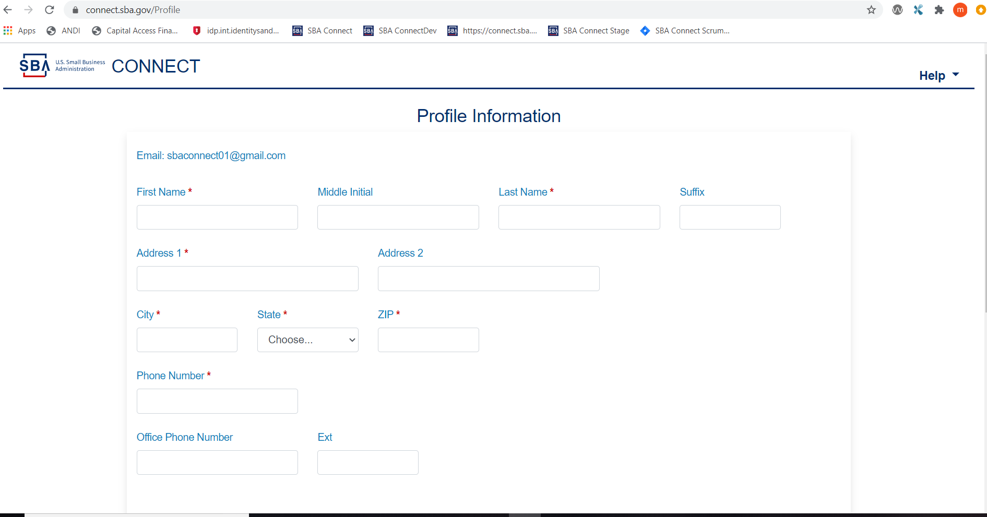

1. When enter personal information clicks submit the “Success” message pops up.

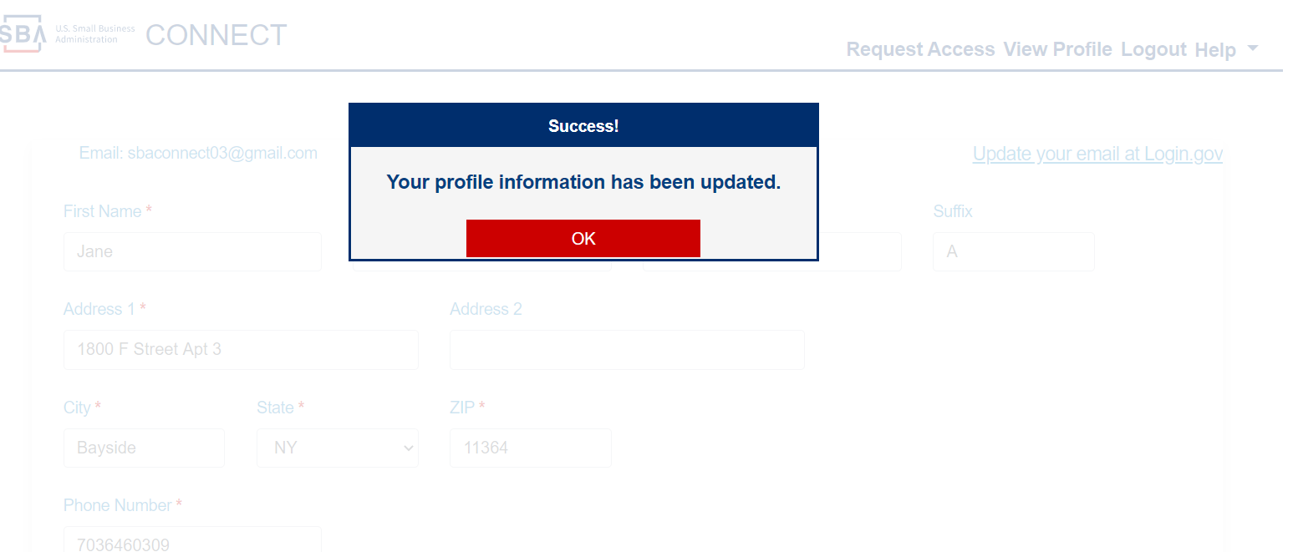

1. When user clicks “OK”, on the pop up message, user will be navigated to the “Claim Business” page of the Certify.

